Ipv4 addressing
32 bits address
4 0ctate
8.8.8.83
Class A 0XXXXXXX
Class B 10XXXXXX
Class C 110XXXXX
Class D 1110XXXX
Class E 1111XXXX

Ip address had two parts
Network id/address host id/address

Subnet mask
Class A 255.0.0.0
Class B 255.255.0.0
Class C 255.255.255.0
Class D 255.255.255.255
Class E

If you make all network bits one [ 1 ] then you get subnet mask.
And you write network bits from left to right and host bits from right to left

Logical and operation in ip address and subnet then you get network id

When all host address is 0 then it is the network address/id

If all host bits are one [ 1 ] then it is the broadcast ip for that network
Eg :- 1.255.255.255

Non routable ip address

Private ip vs public ip

Private ip ranges in each class

169.254.x.x automatic private IP address APIPA

Subnetting

Subnetwork

192.168.15.01 000000 subnet address
192.168.15.01 000001 192.168.15.65
192.168.15.01 111110 192.168.15.126
192.168.15.01 111111 192.168.15.127

172.16.0.0/20
11111111.11111111.11110000.00000000
255.255.240.0

10.0.0.0/14
11111111.11111100.00000000.00000000
255.252.0.0
256-252 = 4
So range is 0,4,8,12….252

10.0.0.0/14
10.4.0.0/14
10.8.0.0/14
.
.
.
10.252.0.0/14

10.0.0.1/14 1st valid
10.3.255.254/14 last valid
10.3.255.255/14 broadcast

Flsm all this…

Fixed length subnet mask

Variable length subnet msk [VLSM]

192.168.20.0/24

Day 2 cisco packet tracer Monday 12-10-2026

Switch
Storage components
ROM – Firmware
RAM – running configuration [current configuration]
NVRAM – startup configuration [ changed configuration settings stored in the NVRAM ]
Flash – IOS

Booting Process
- ROM performs POST [ Power on self test ]
- Load the ISO from flash to RAM
- Load the configuration settings from NVRAM to RAM
- You will switch user mode.

Switch Modes
- User mode
- Privilege Mode
- Global configuration mode
- Specific configuration mode
  - VLAN
  - LINE
  - Interface

Other modes
- Setup mode : Initial configuration when start the switch/router
- ROMOM mode : While loading the IOS from flash to RAM [press CTRL + C to enter into rommon mode
  - We use this mode to recover password by setting register value to 0x2142 to skip NVRAM setup configuration
  - If IOS is corrupted you can restore from TFTP server

Tasks
- How to switch from one mode to another mode
- Use show command to check the RAM NVRAM and Flash memory content.
- Use copy command to copy the configuration from RAM to NVRAM, RAM to TFTP server, NVRAM to RAM, Flash to TFTP server, TFTP server to Flash.
- Set the password for console port , telnet access, privilege mode.
- Access the switch through console port, access the switch remotely using telnet and SSH

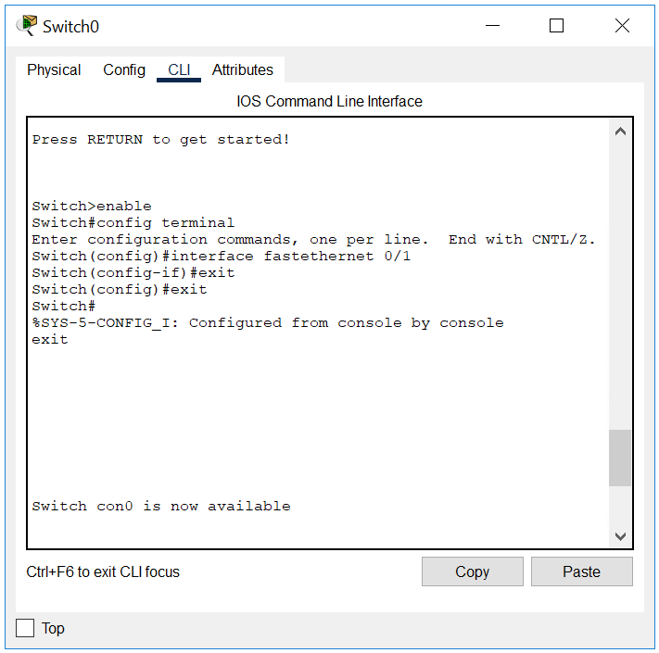
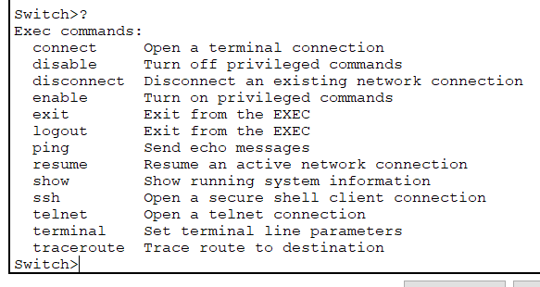

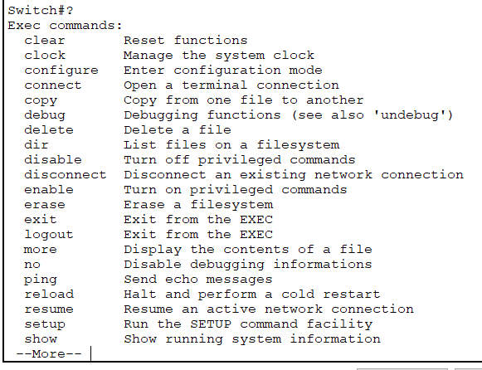
Press enter enter to view more commands

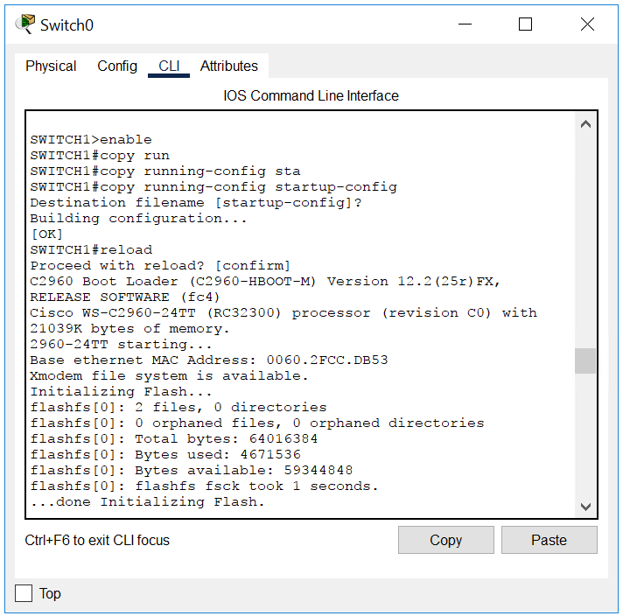
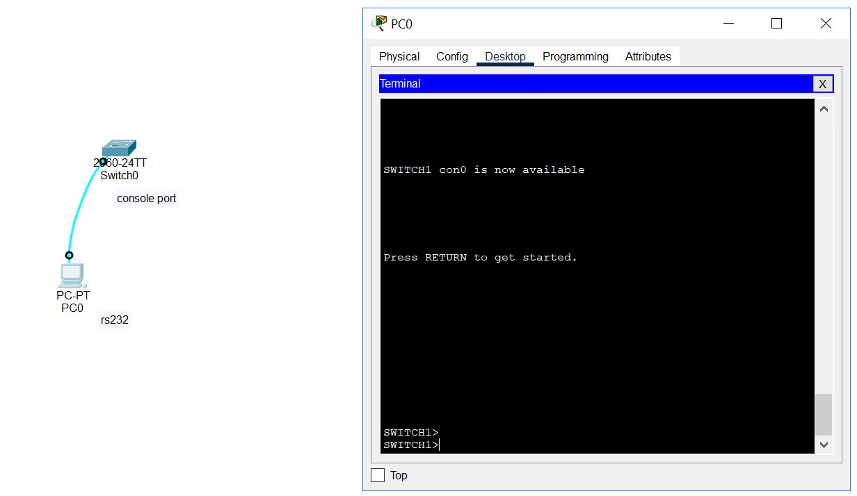
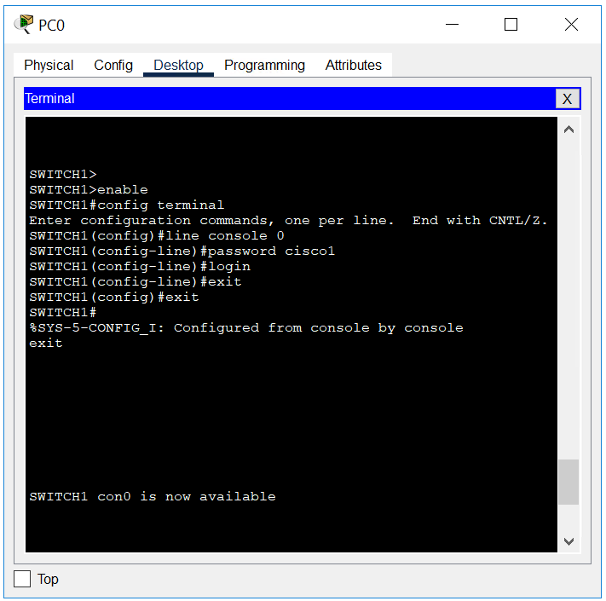

Day 3 oct 13

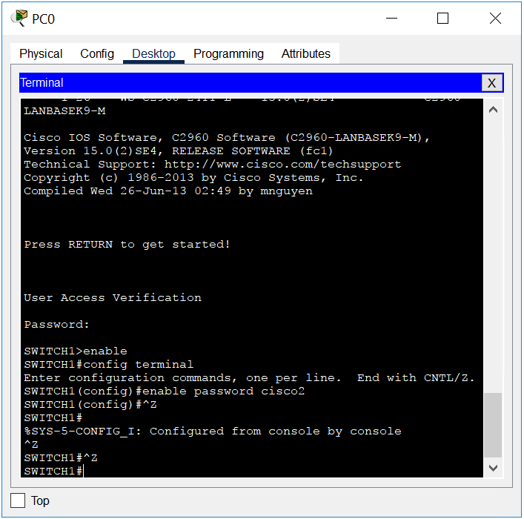
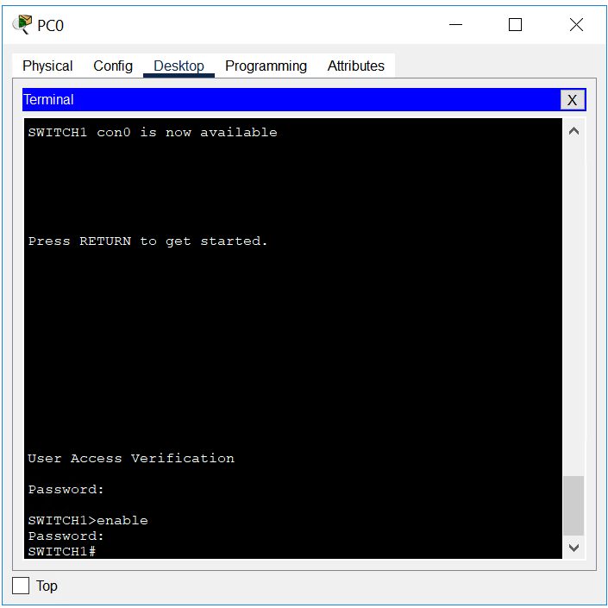
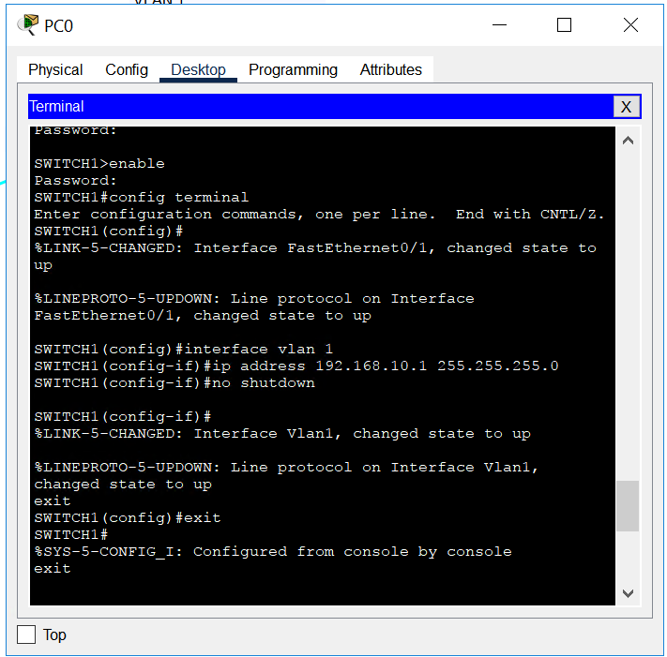
Show running-config

No ip domain-lookup command to ignore wrong command

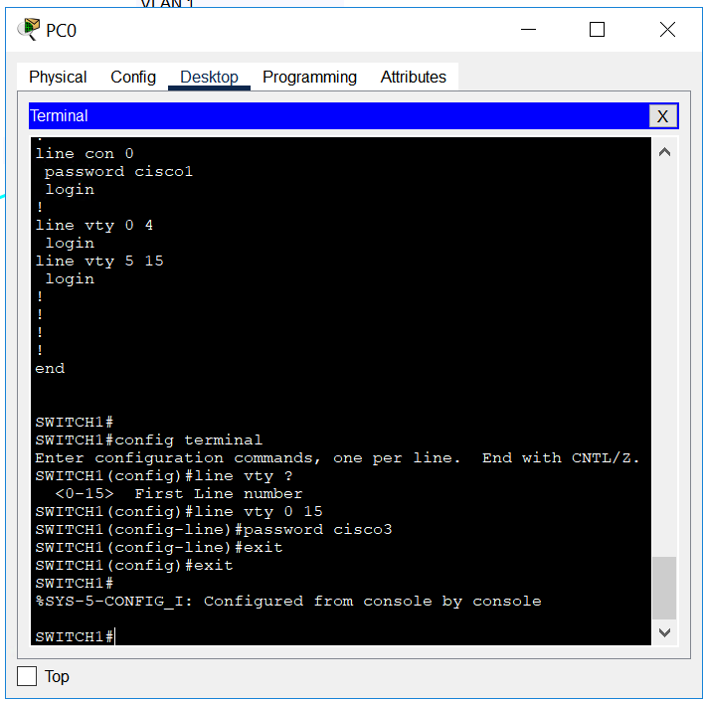
telnet

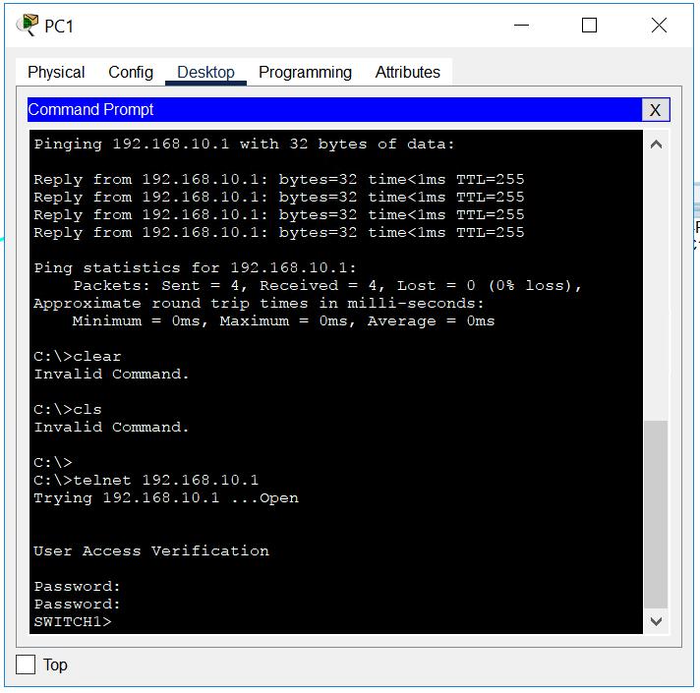

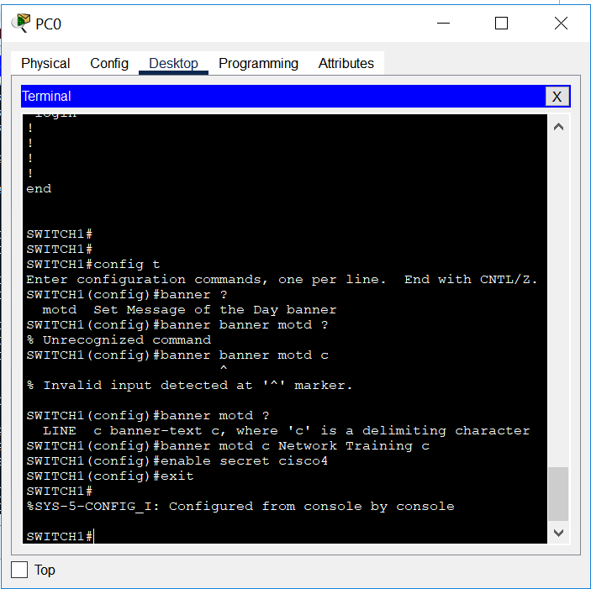

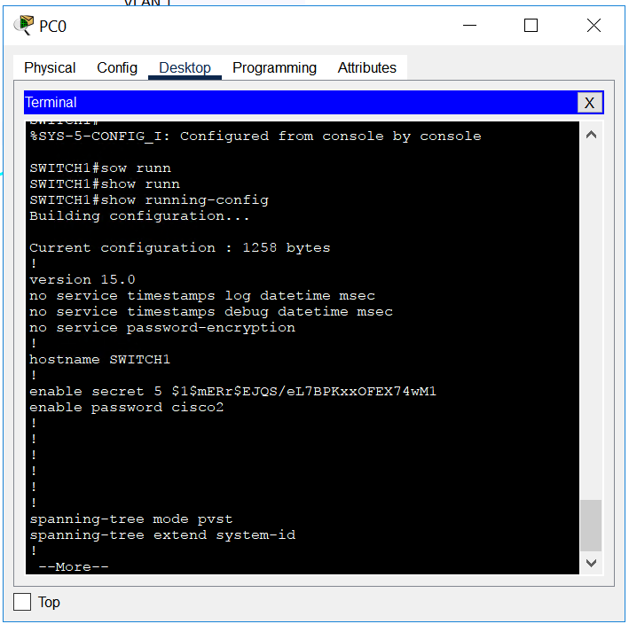

Verify banner [through terminal or switch cli] and secret password [ when you change the mode from user priviledged mode]
Secret password override clear text password of priviledged level password

ROUTER
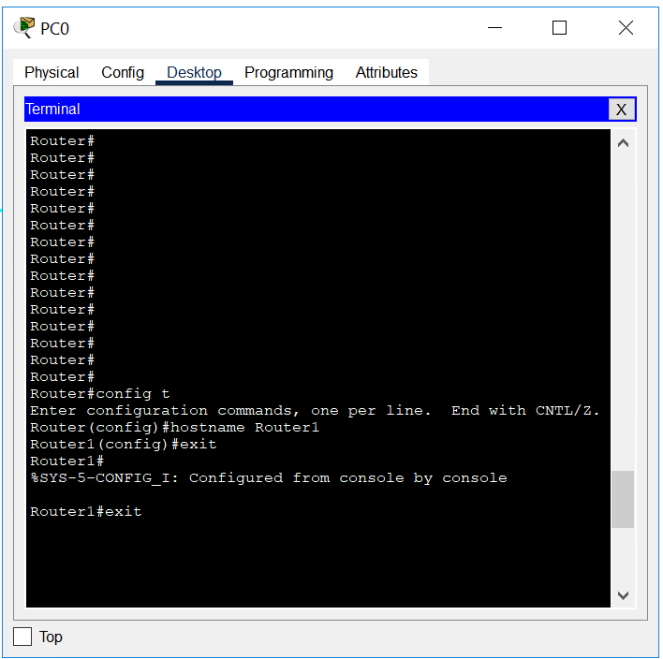
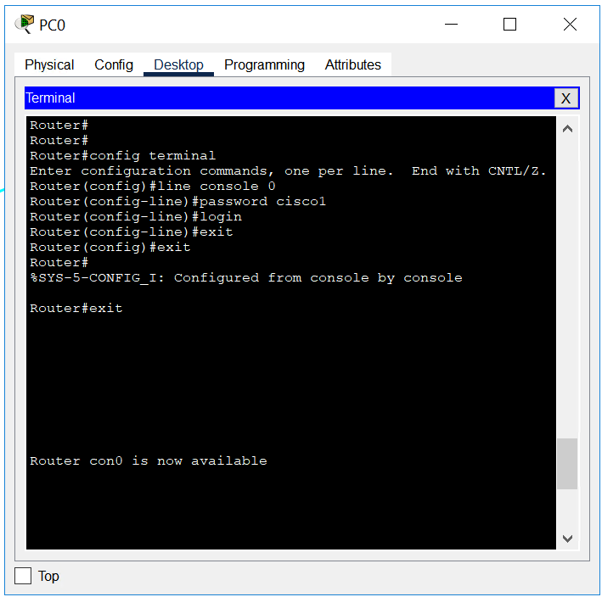
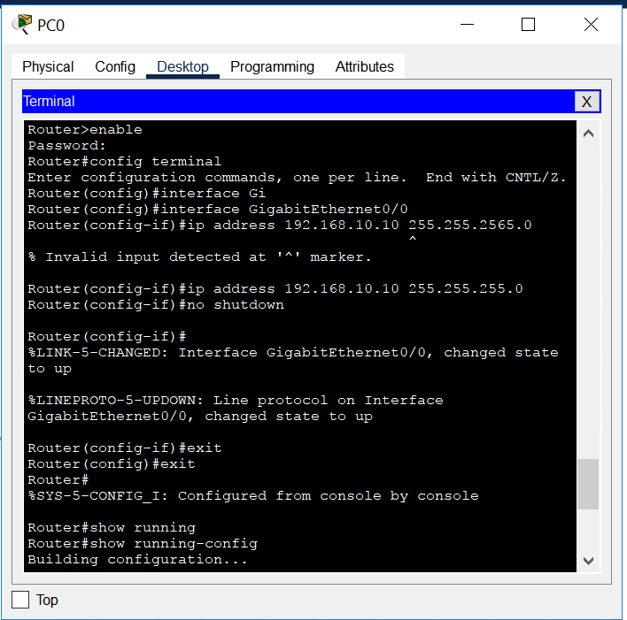
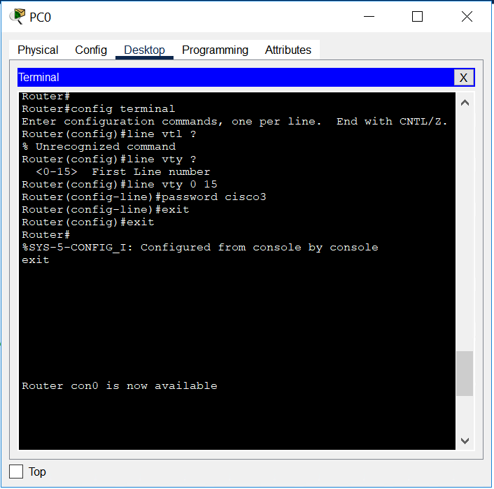
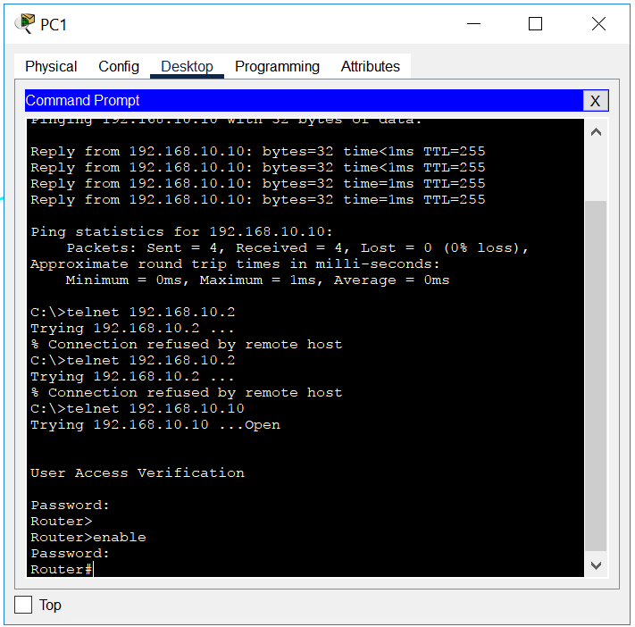

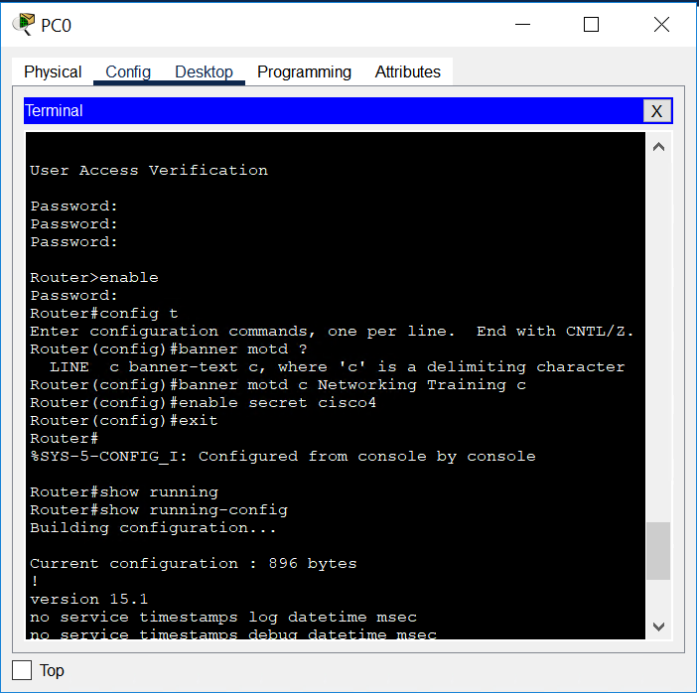

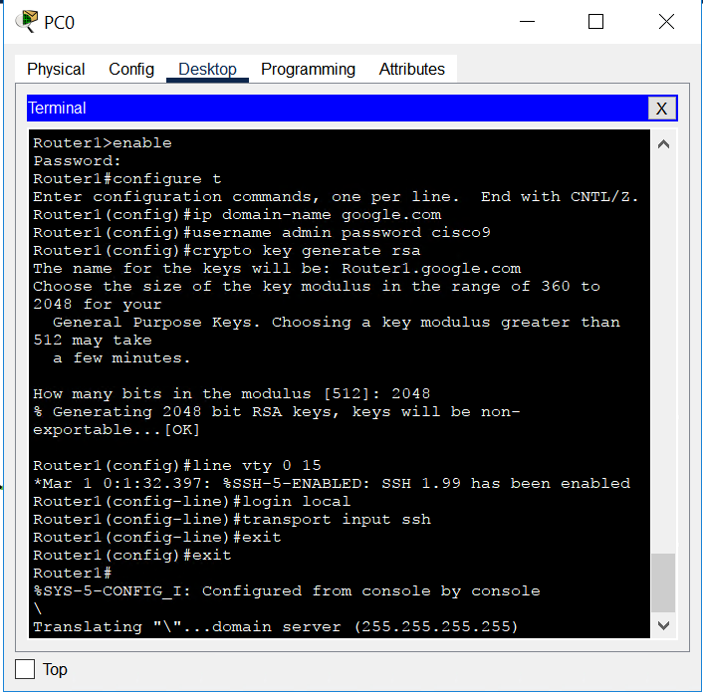

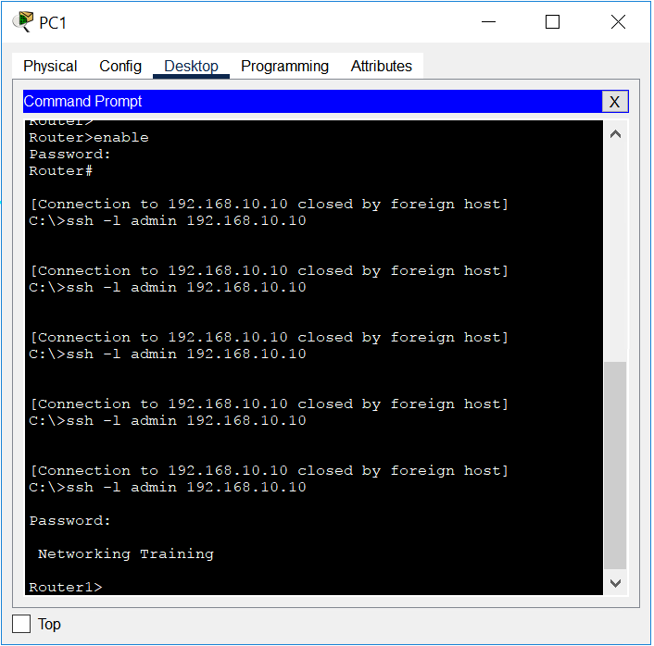
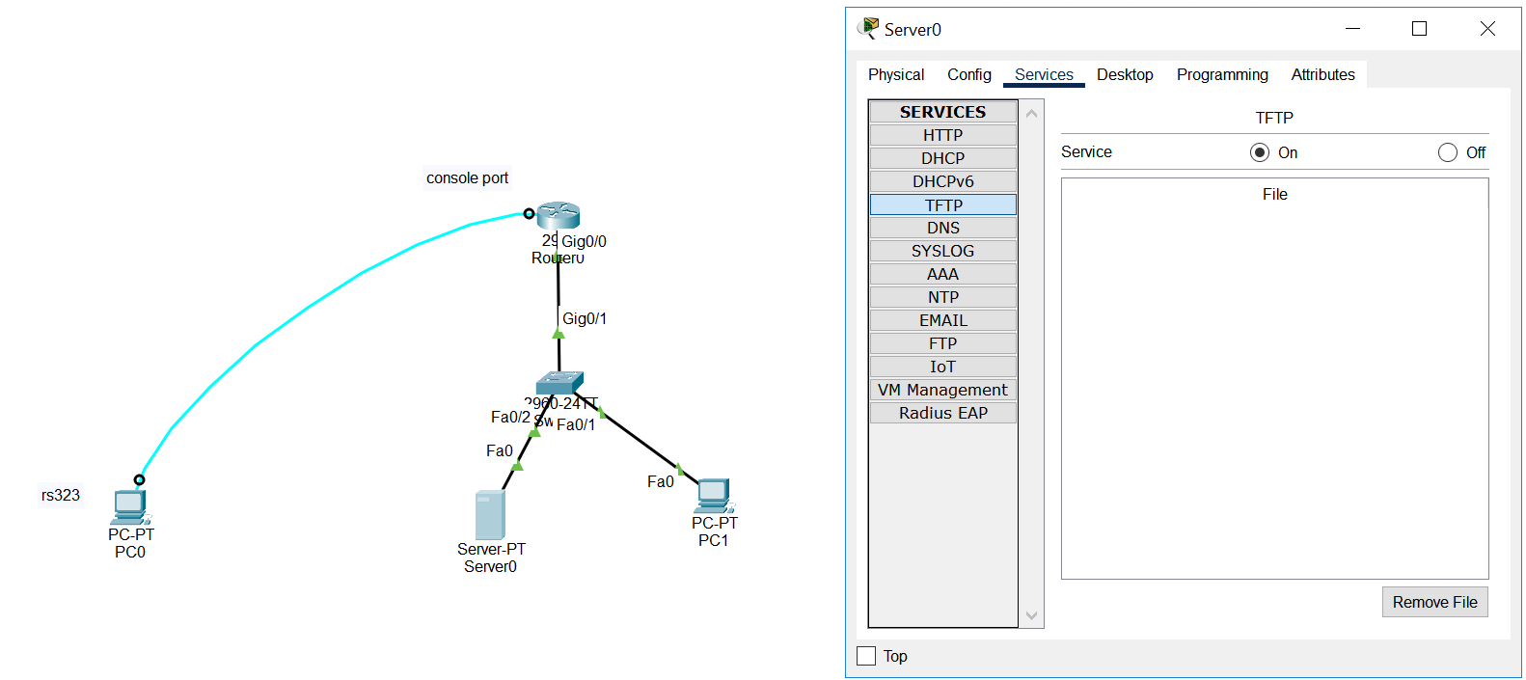

Tftp
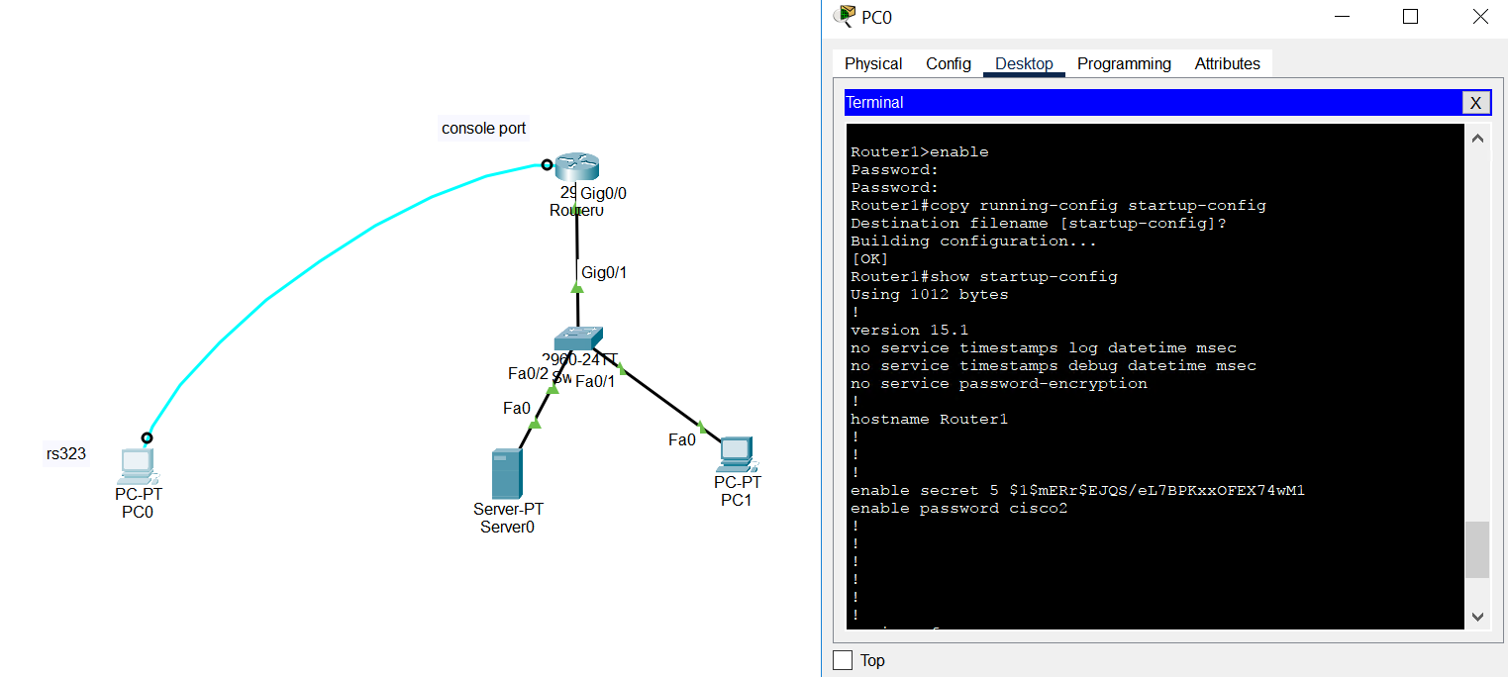
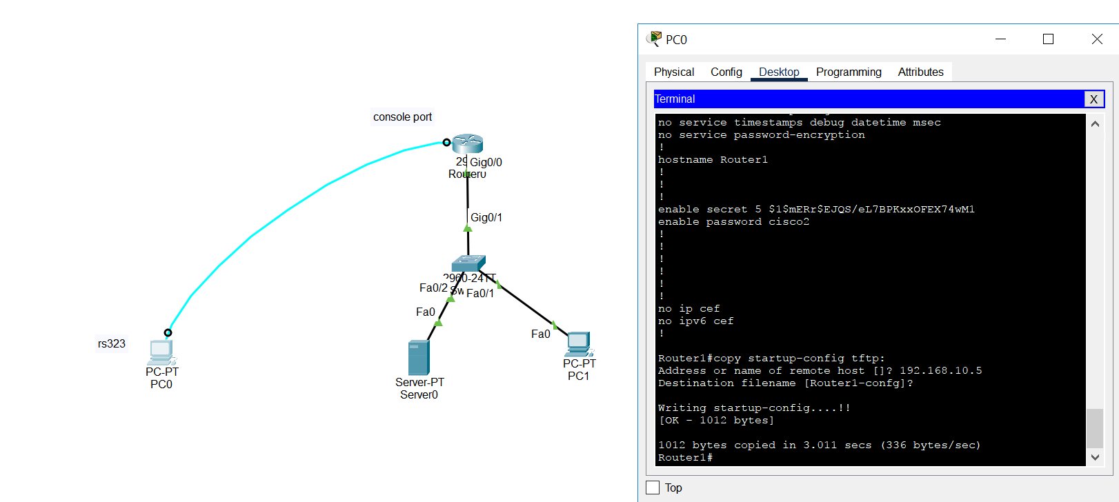

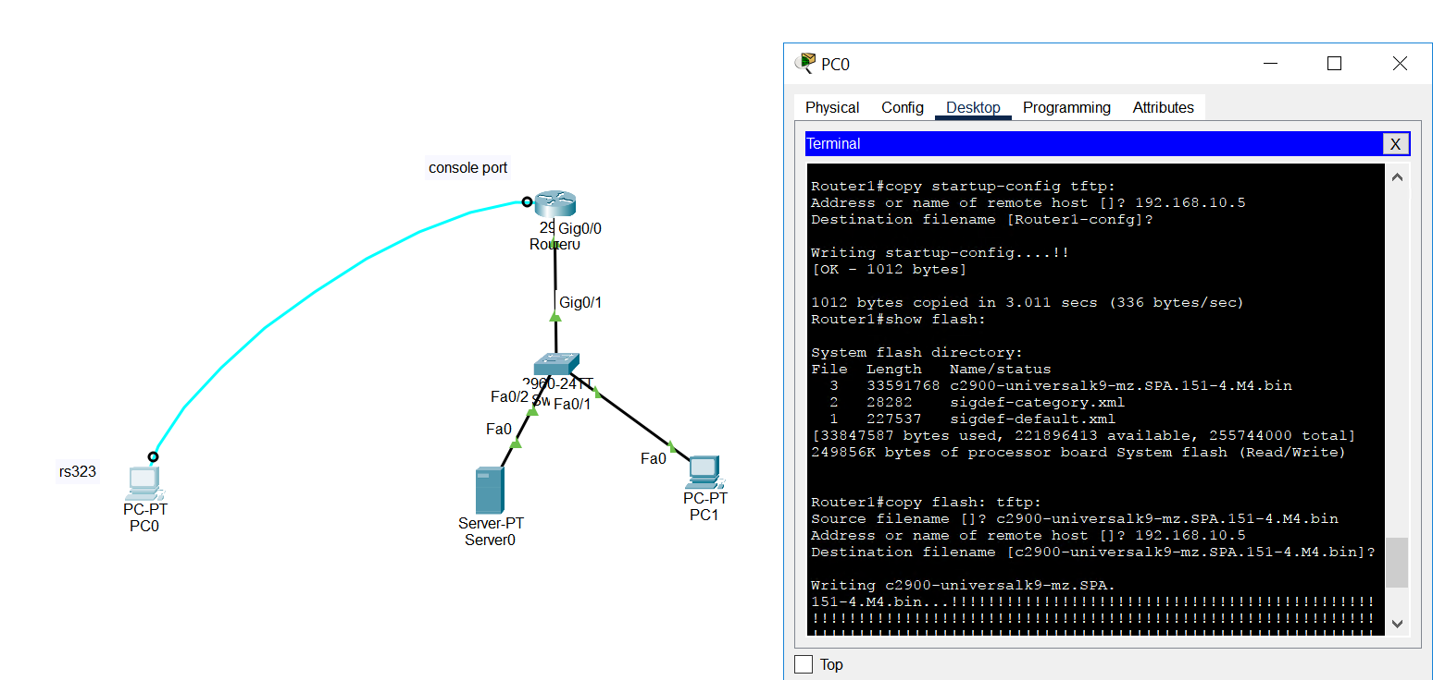
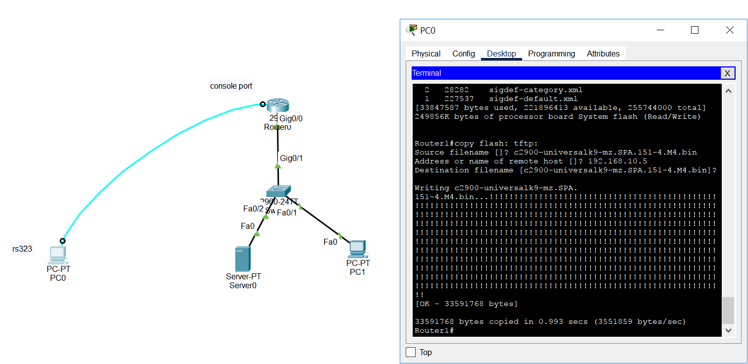

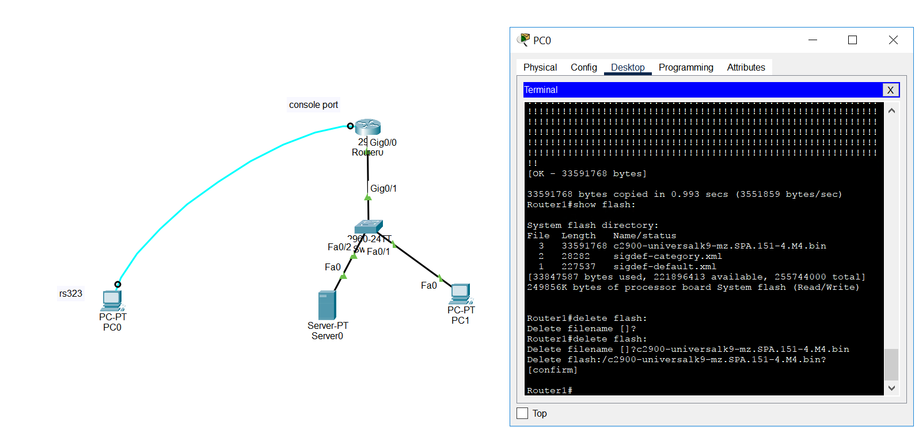

Restoring ios from tftp to router

Refer pics from mobile

RECOVERING PASSWORD
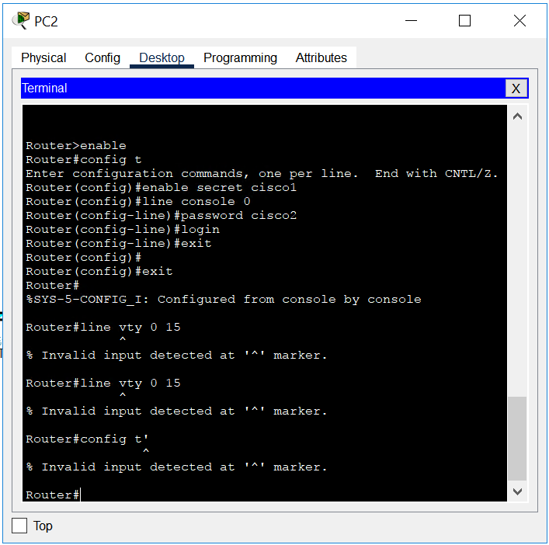

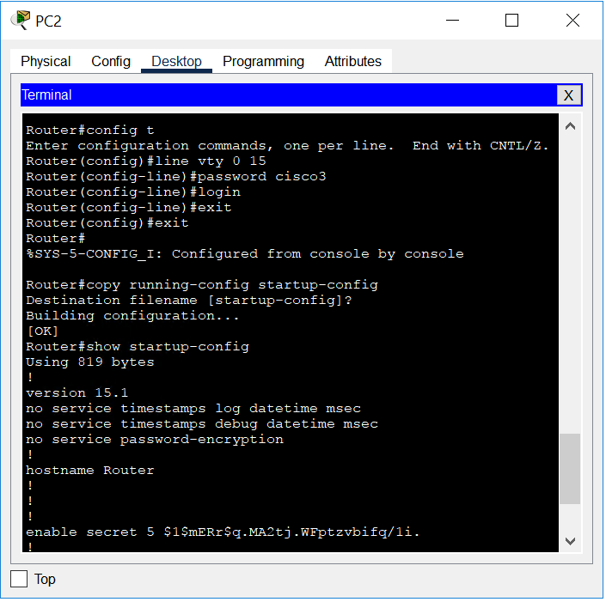
Manually turn off and on the router and press ctrl+c while reloading to enter rommon mode
Further commands in mobile pics

DAY4 Network core 14 October

Routing
Default routing iproute [network id] [subnet mask] [next hop]
Iproute 0.0.0.0 0.0.0.0 11.1.1.2
Static routing R1 iproute 192.168.10.0 255.255.255.0 11.1.1.2
R2 Iproute 192.168.10.0 255.255.255.0 12.1.1.2 R2 Iproute 10.0.0.0 255.0.0.0 11.1.1.1
R3 Iproute 10.0.0.0 255.0.0.0 12.1.1.1

Dynamic routing ínterior gateway routing protocols [single autonomous system]
RIP EIGRP[cisco proprietary] OSPF IS-IS
External gateway routing protocols
BGP

RIP | EIGRP | OSPF
120 Administrative distance | 90 | 110
Distance vector [bellman forte] | DUAL | djikstra
15 hops supported | No limit | No limit
Hop count Cost metric | Bandwidth, delay, reliability,load mtl[max transition load] | bandwidth
Numbered hop formula | 256x(bandwidth+delay) | Reference bandwidth / Interface Bandwidth

Classless scenario

Routing practicle
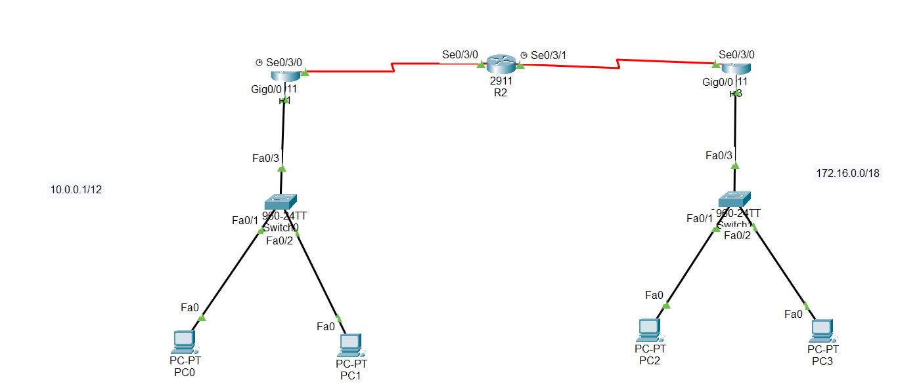
Commands in mobile pic

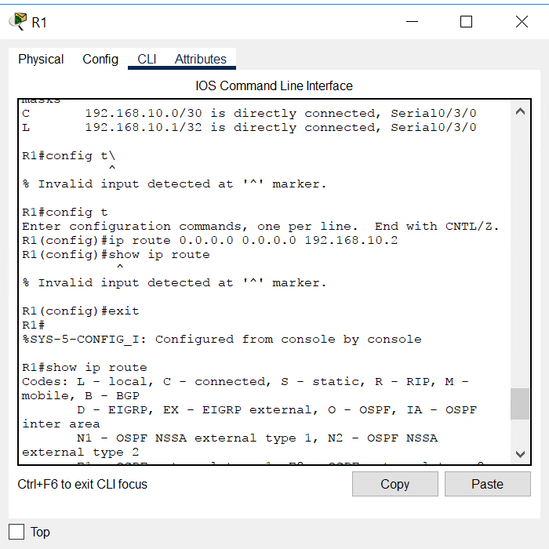
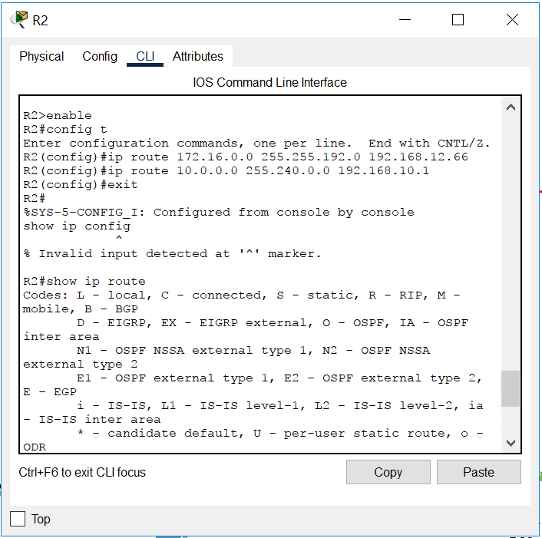
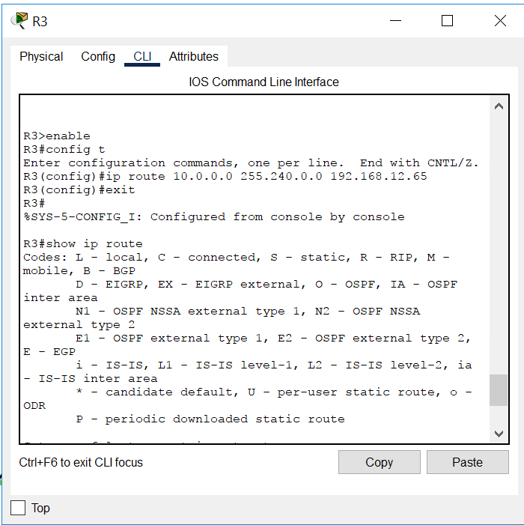
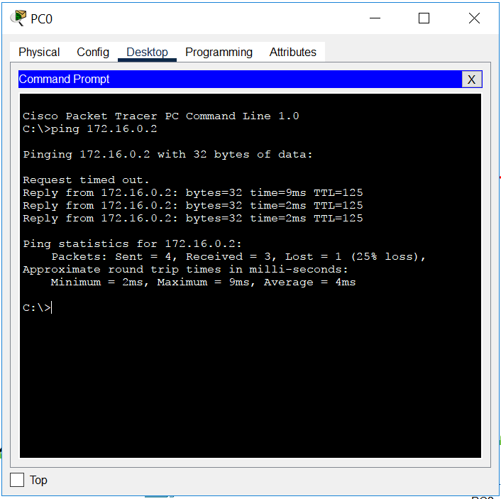

DYNAMIC ROUTING
RIP
Commands in mobile pic
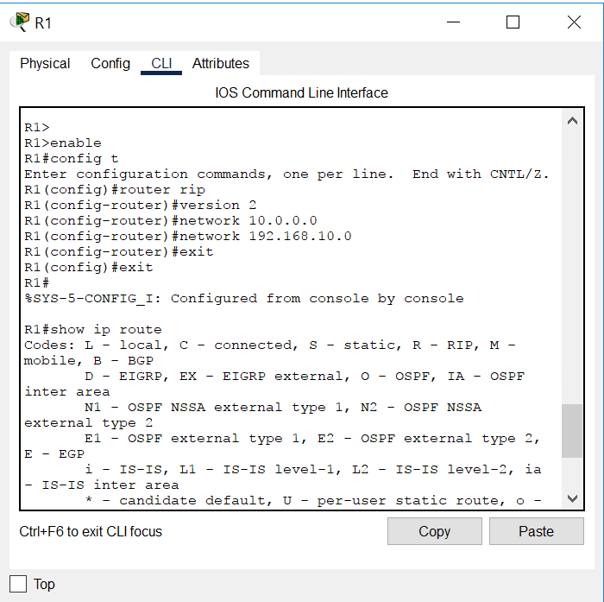
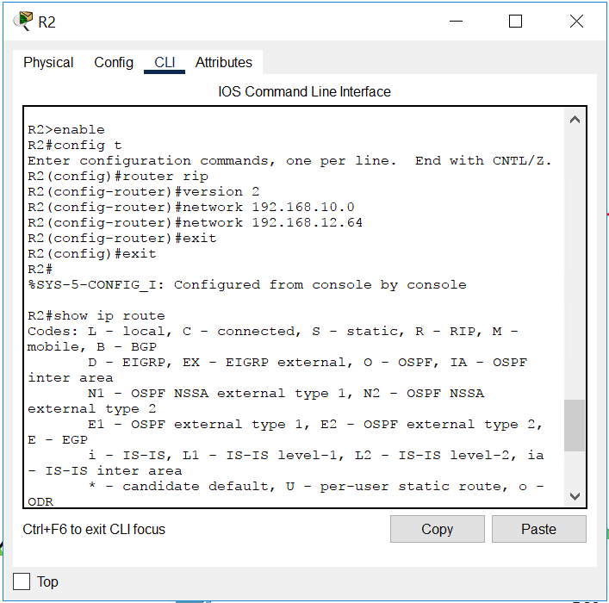
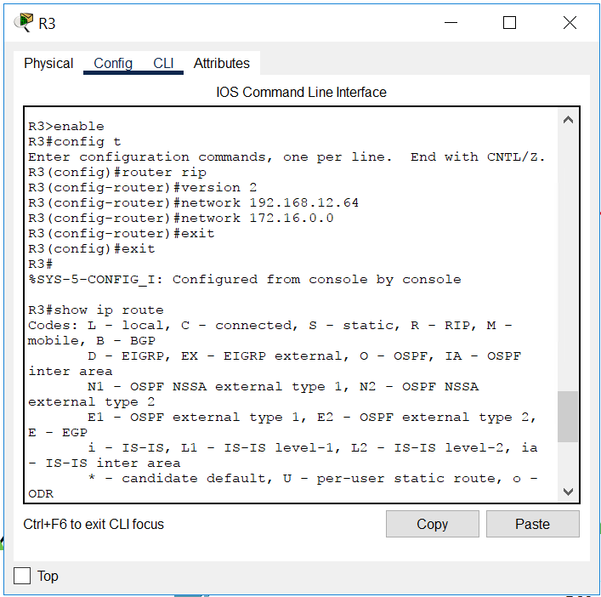
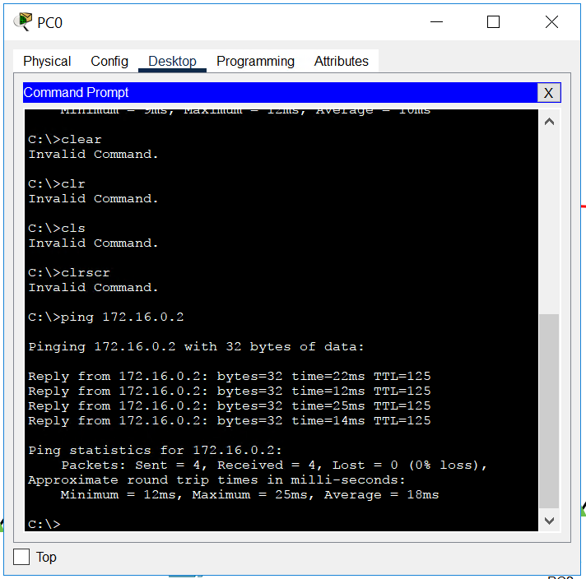
EIGRP
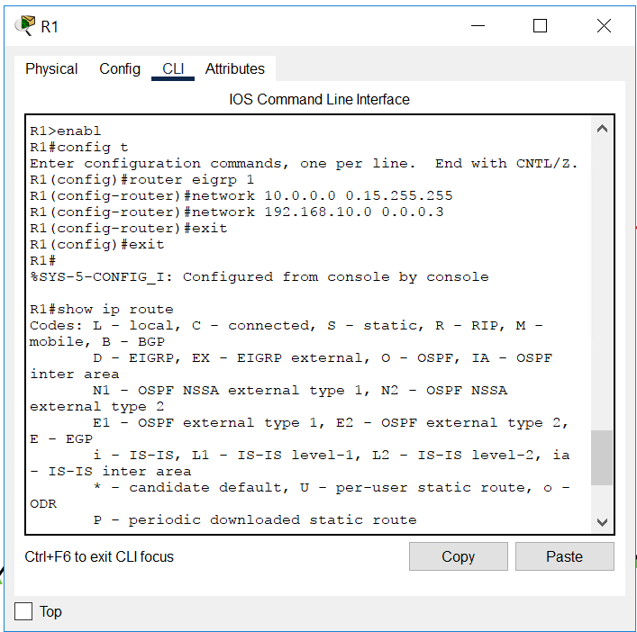
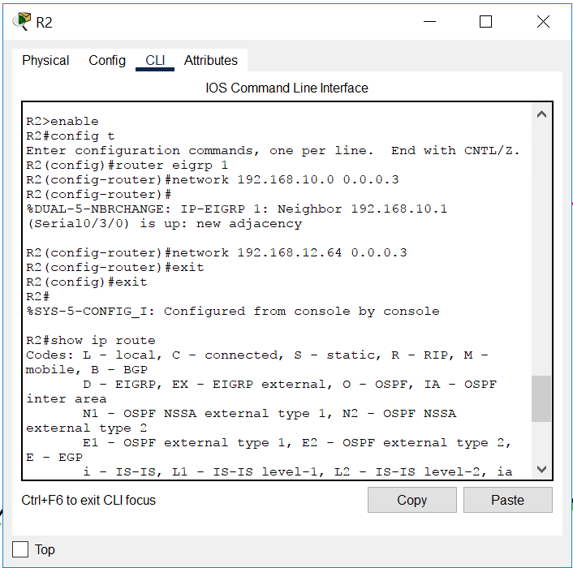
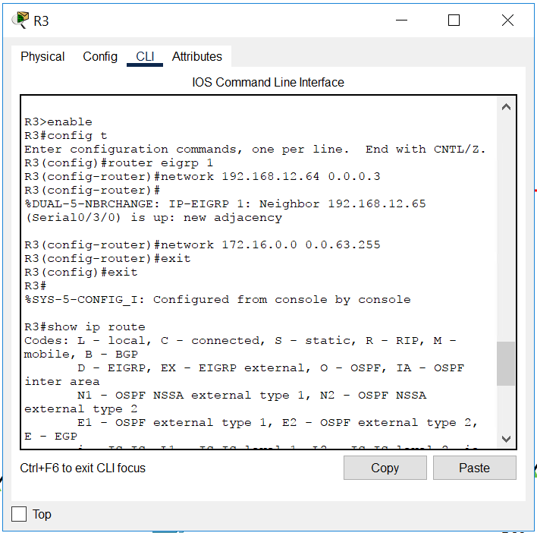
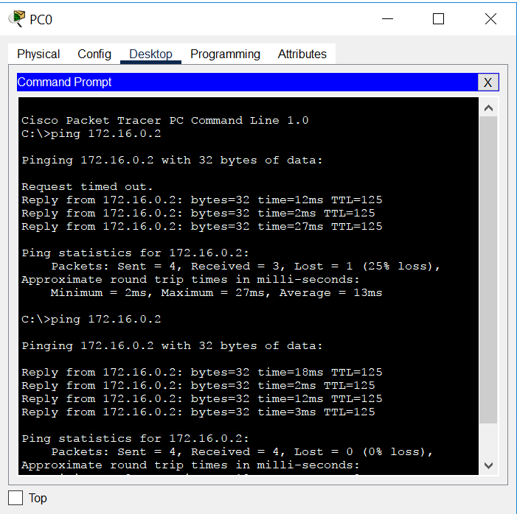

OSPF ROUTING
Commands in mobile pics
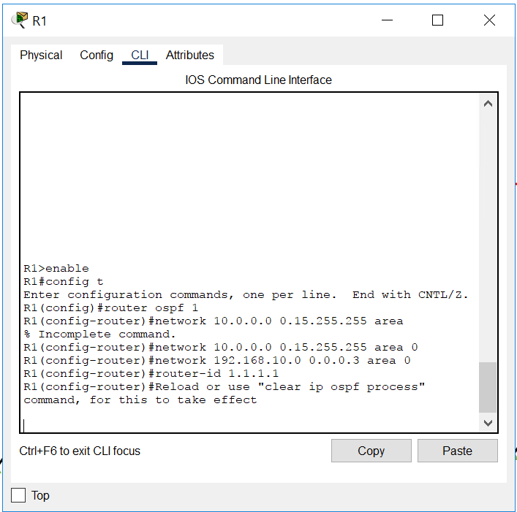
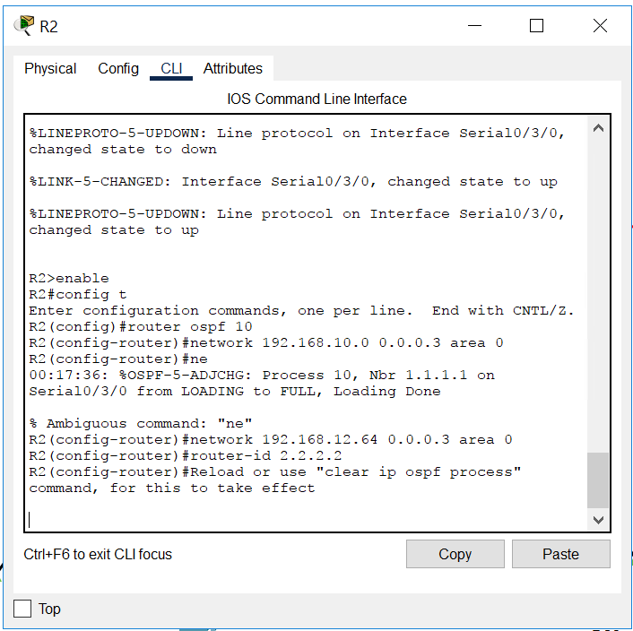
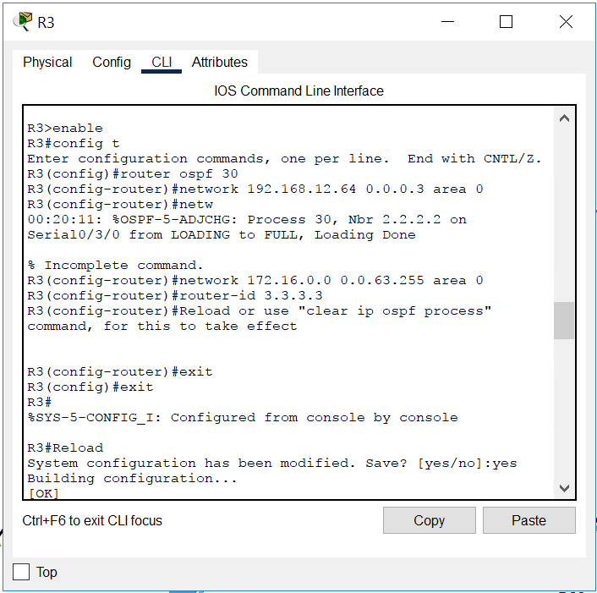
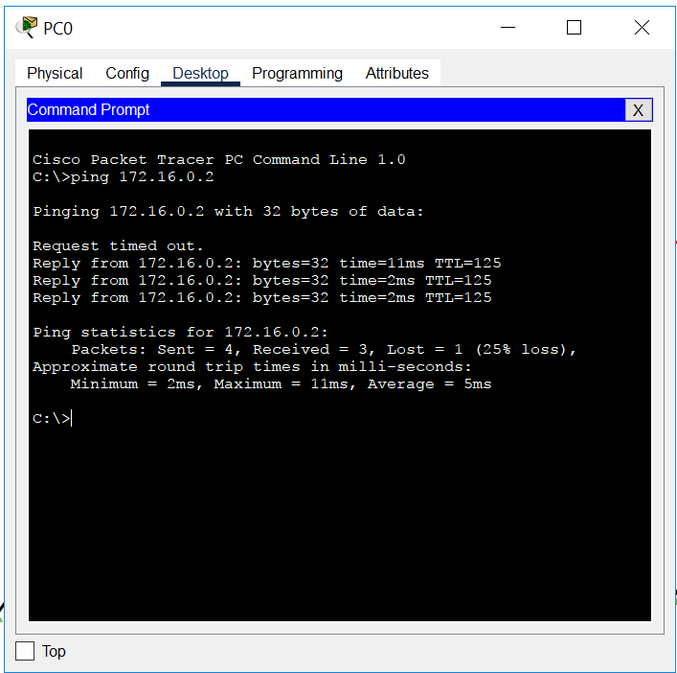

DAY 5 October 15, 2026

ACL
Access control list
Allow or block packets based on IP, protocol and port no.
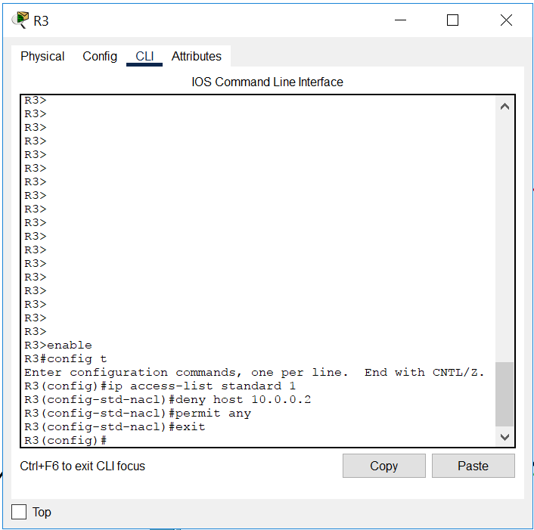
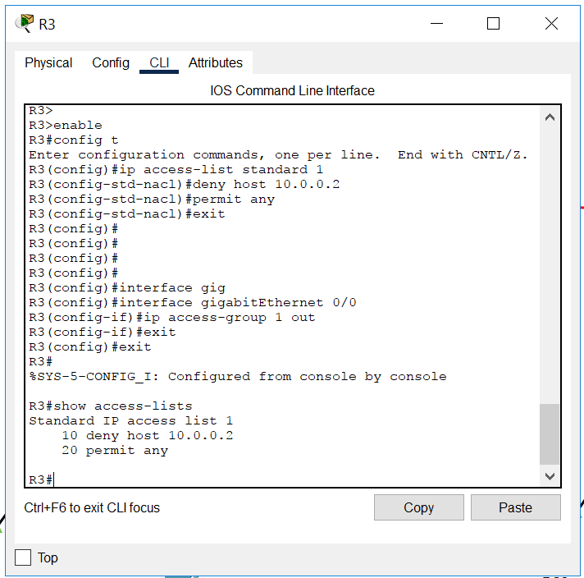
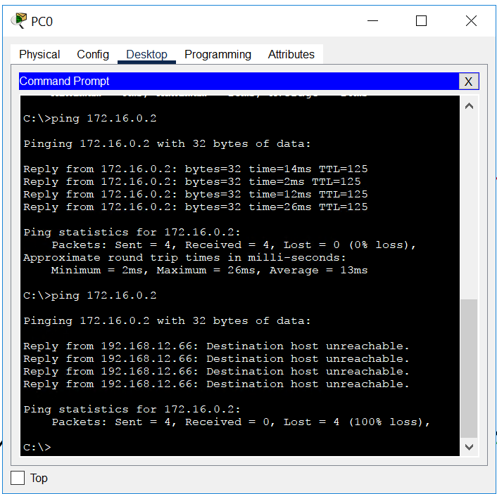
Removing configuration
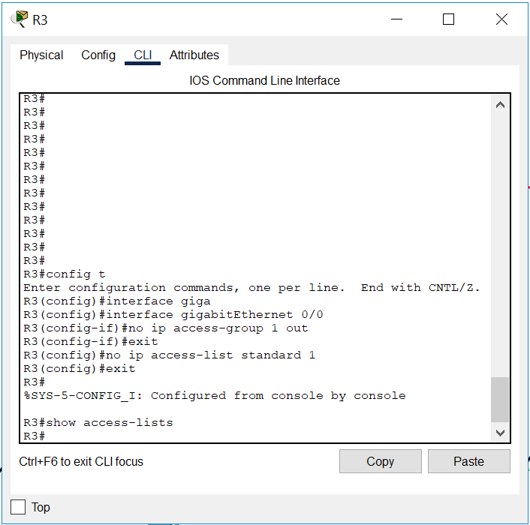
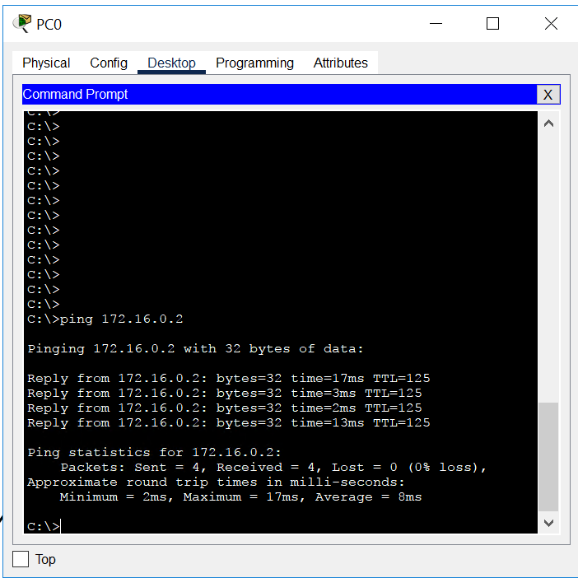

Added server……..pic in mobile
Extended ACL
Pics in mobile
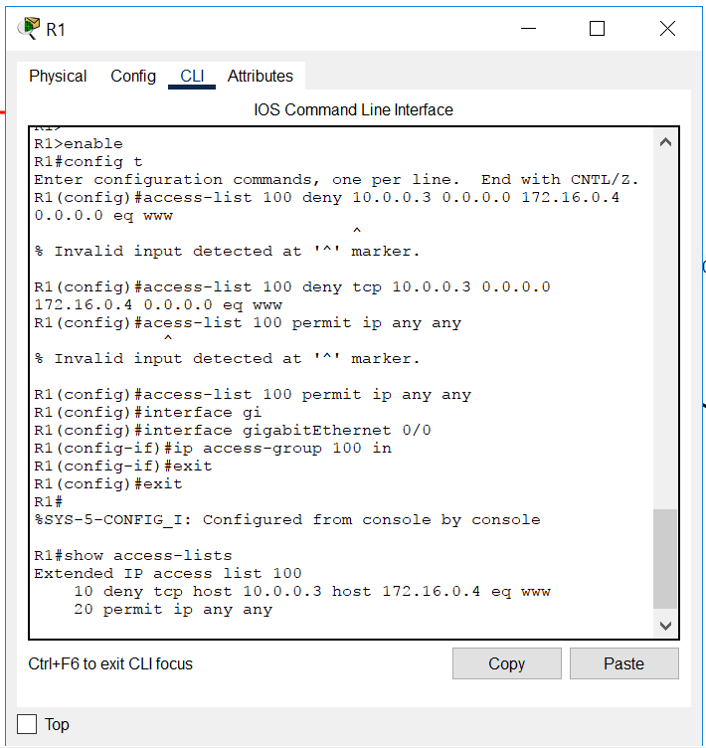
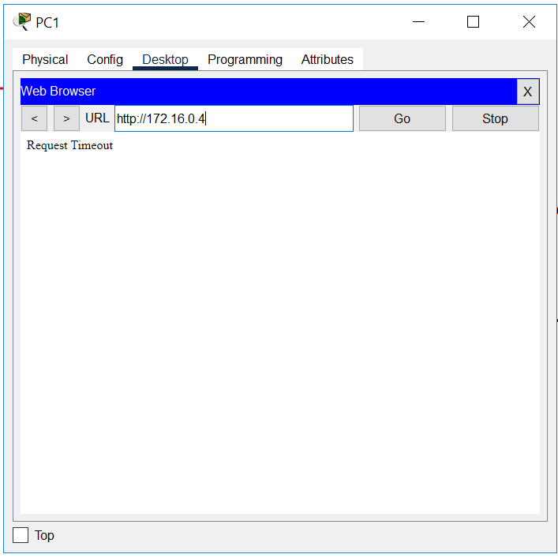

Task 3 TELNET
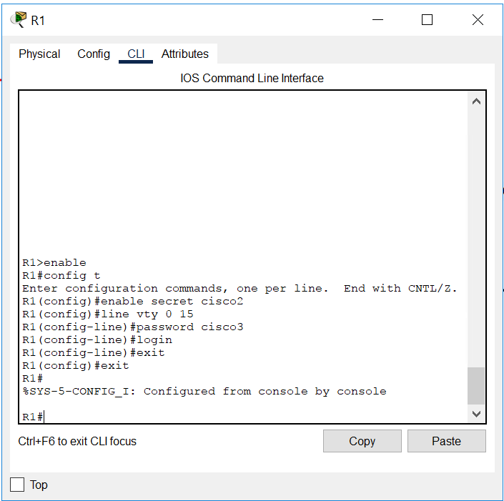
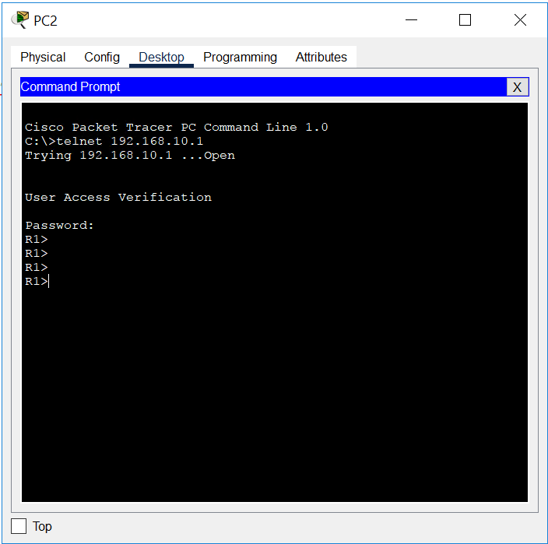
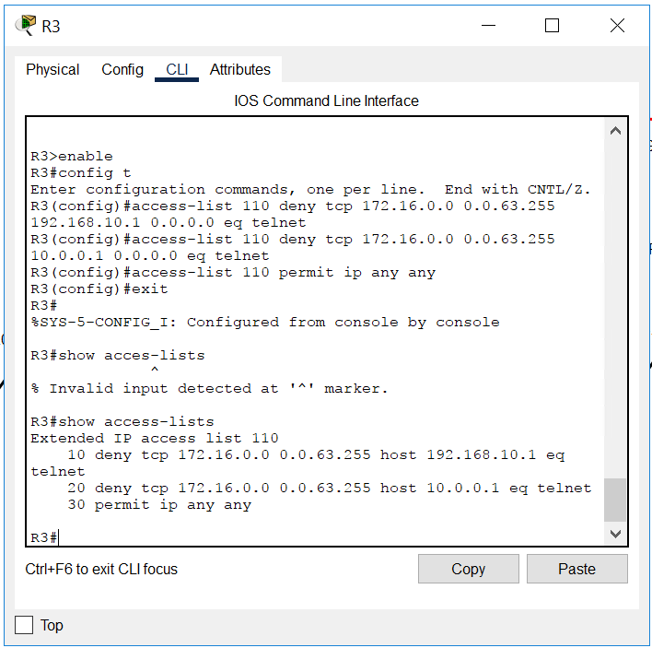
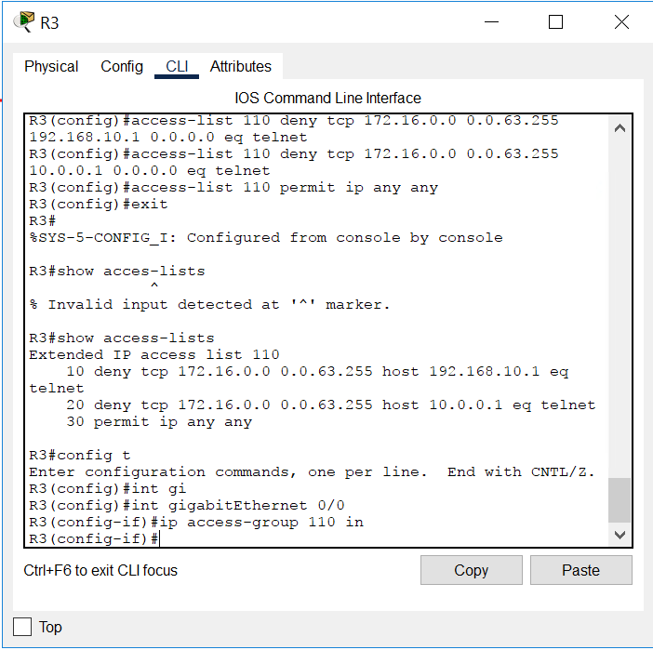
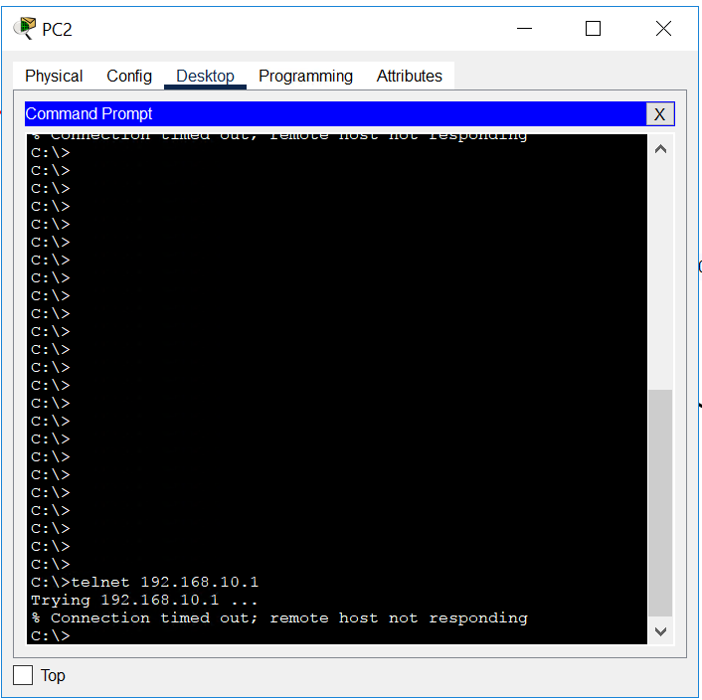

FTP
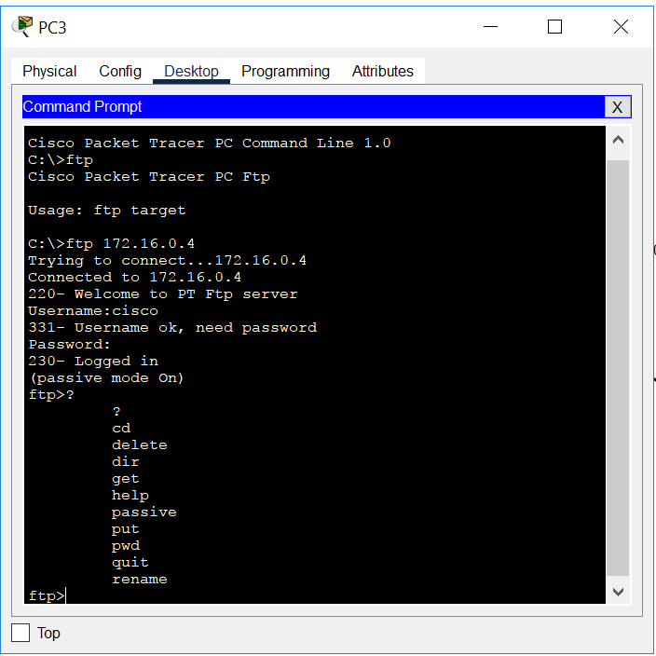
Block ftp commands in mobile

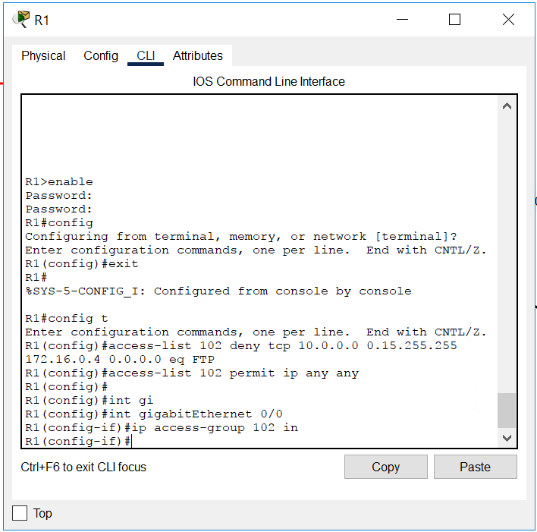
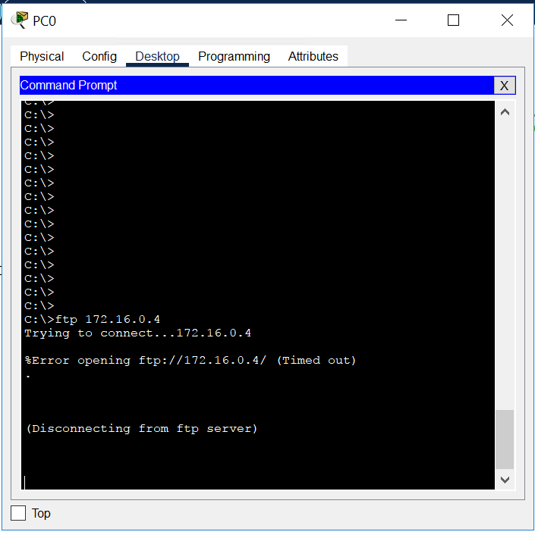

NAT [routing is required… so made copy of eigrp file]
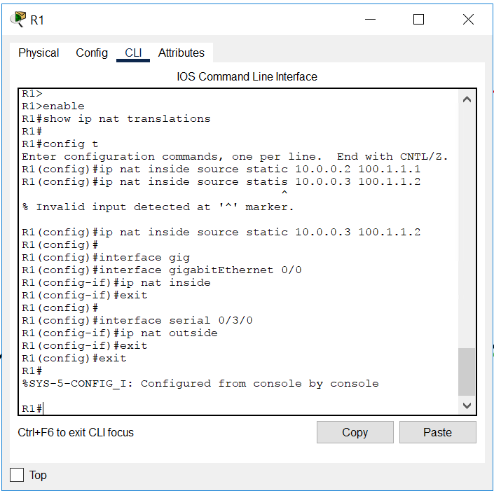
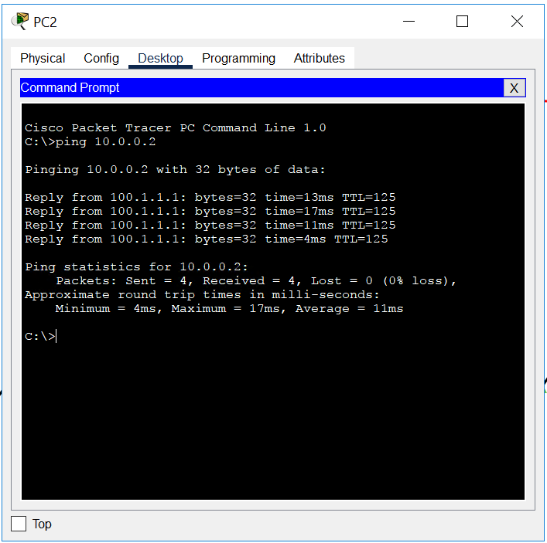
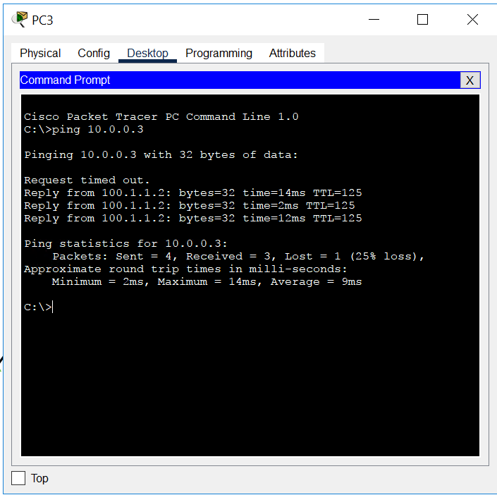
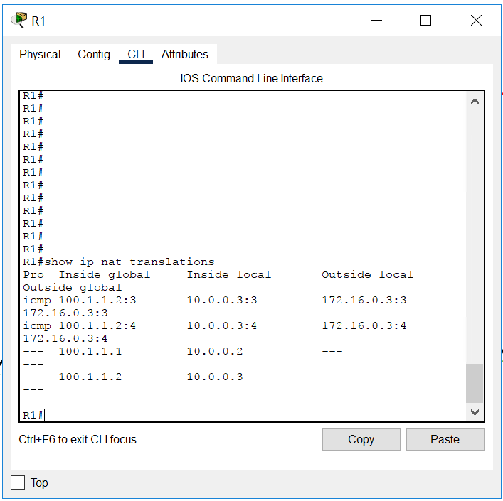

DYNAMIC NAT
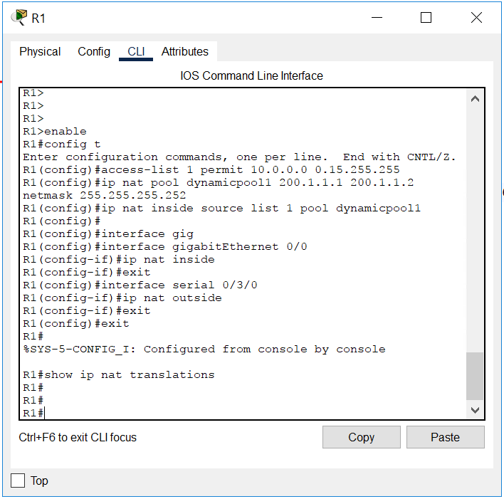
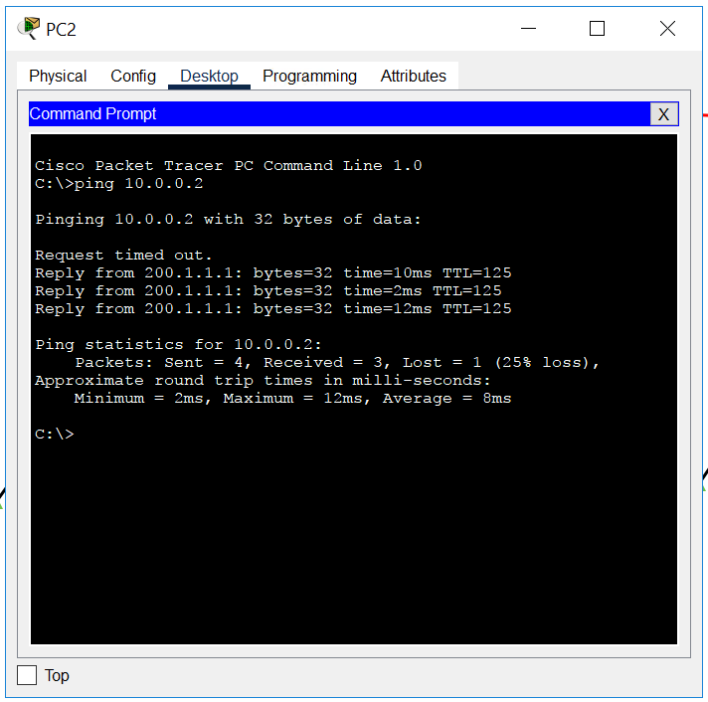
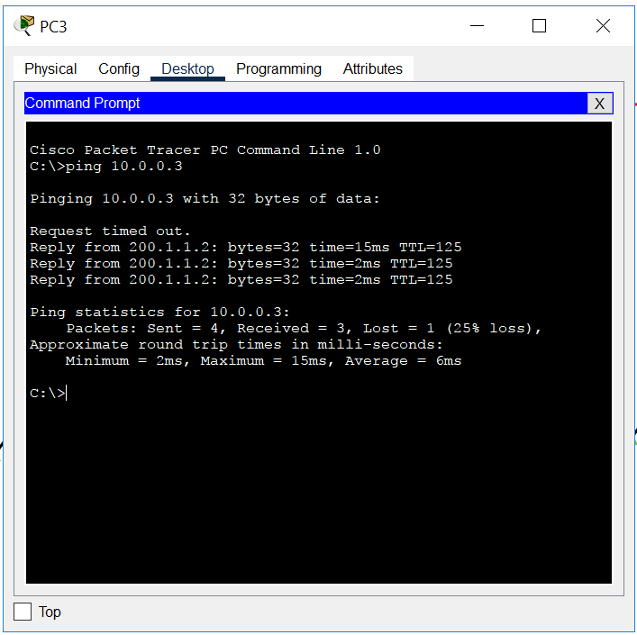
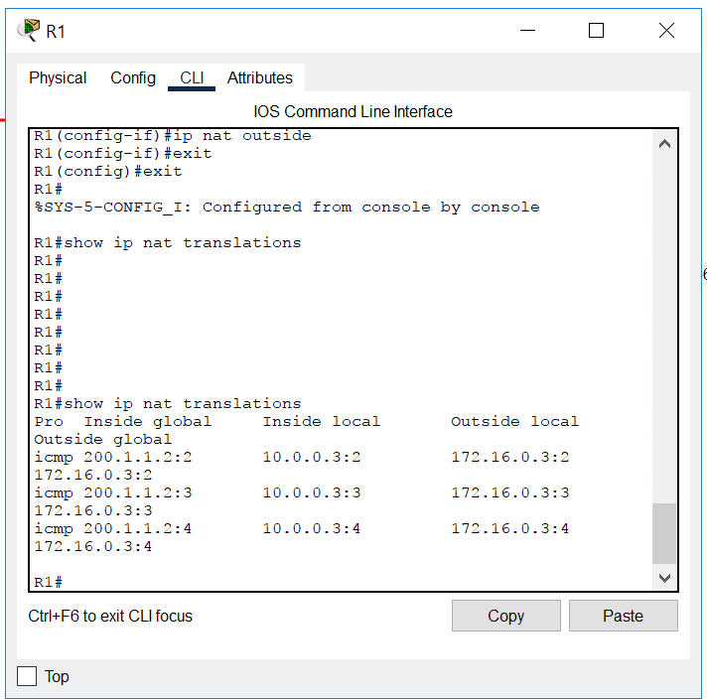

NAT overload PAT
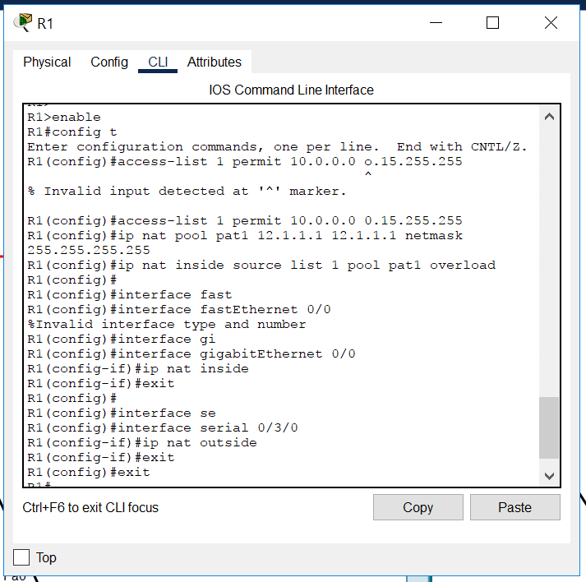
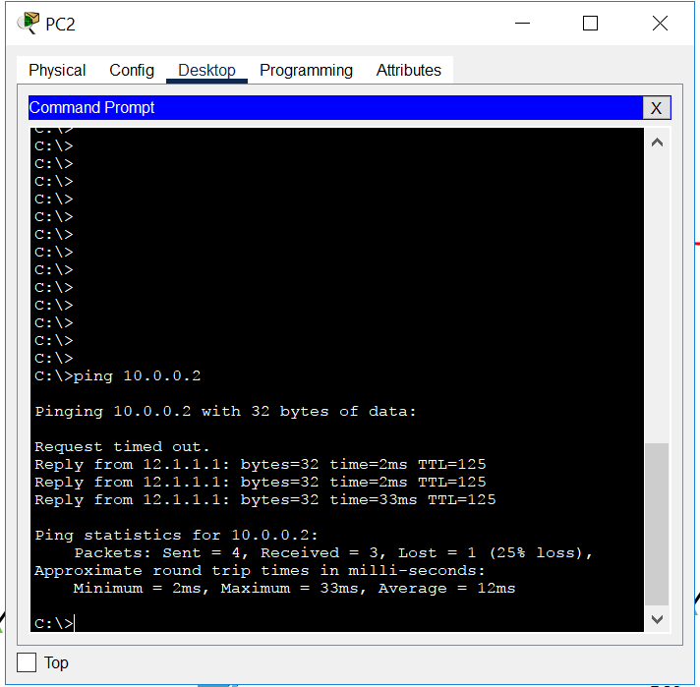
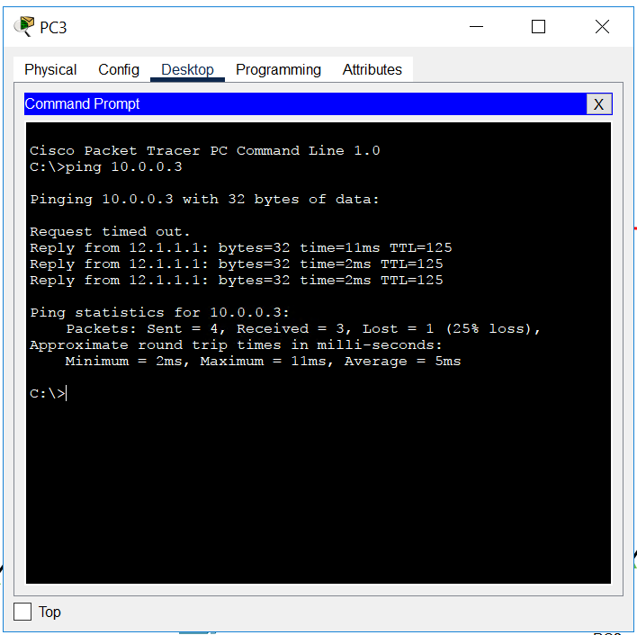
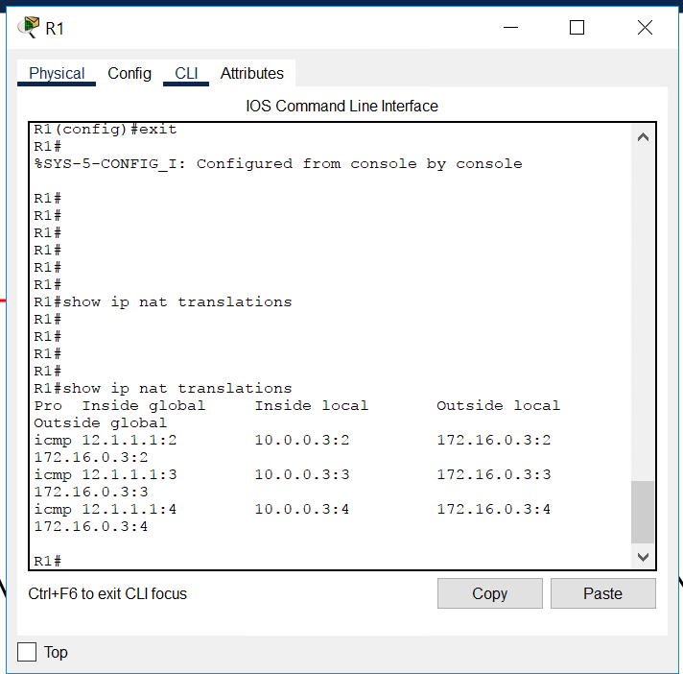

DAY 6 OCTOBER 16
DNS
Port number 53
Tcp udp both

NSLOOKUP [ Name Server Lookup]

DNS Namespace

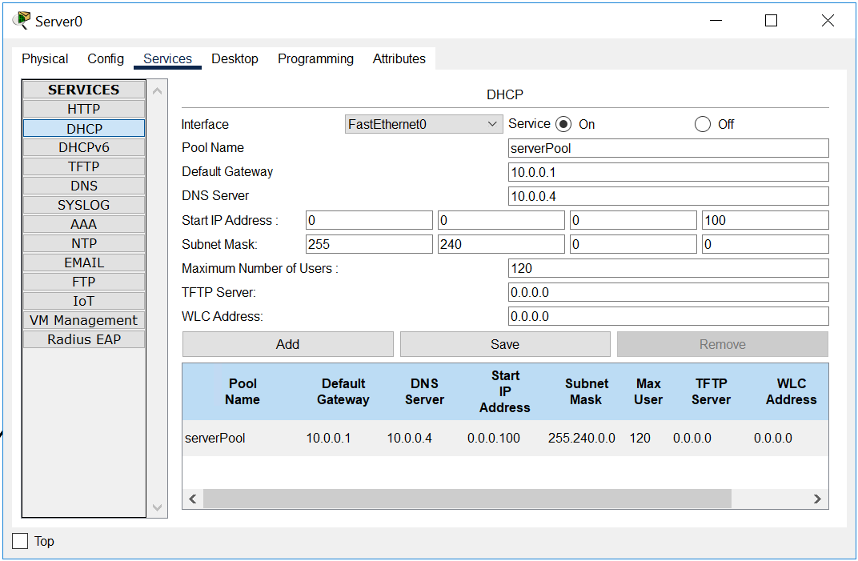

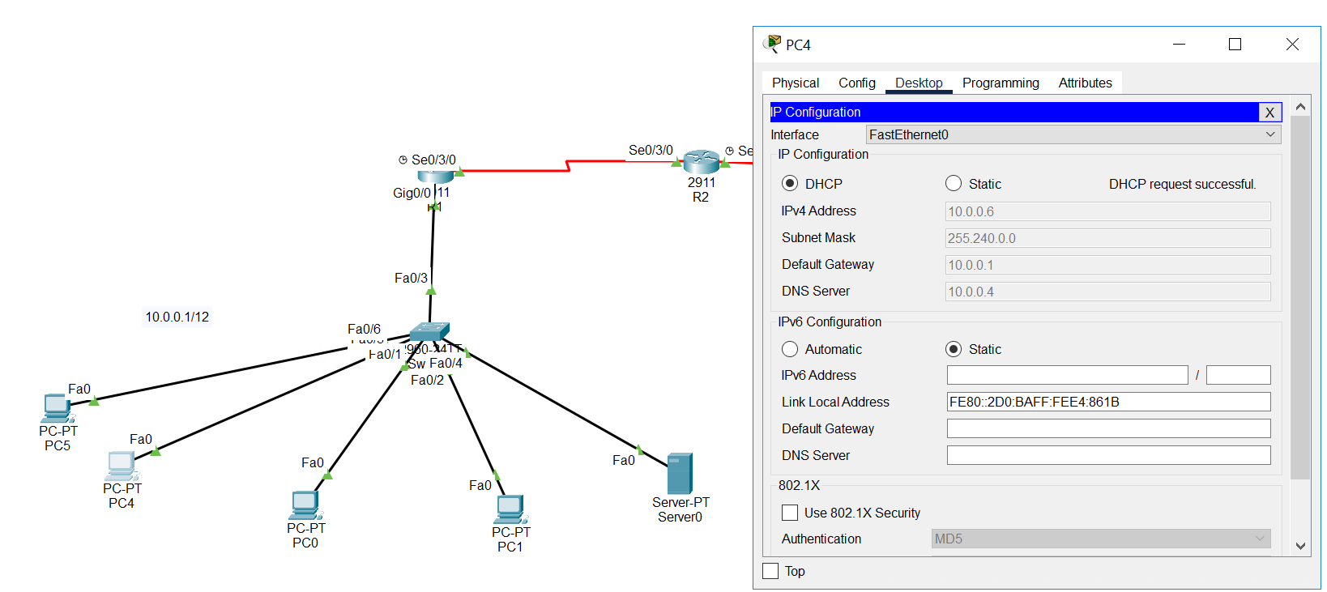
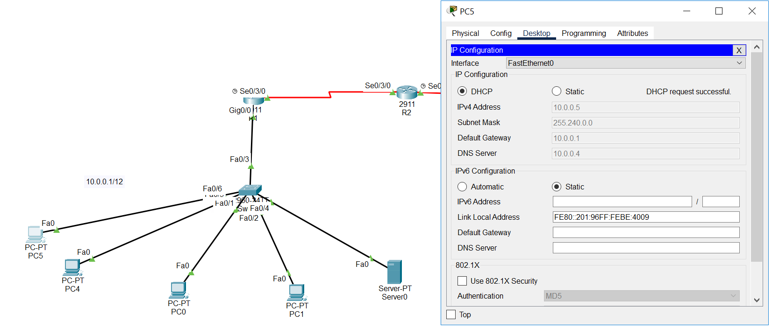

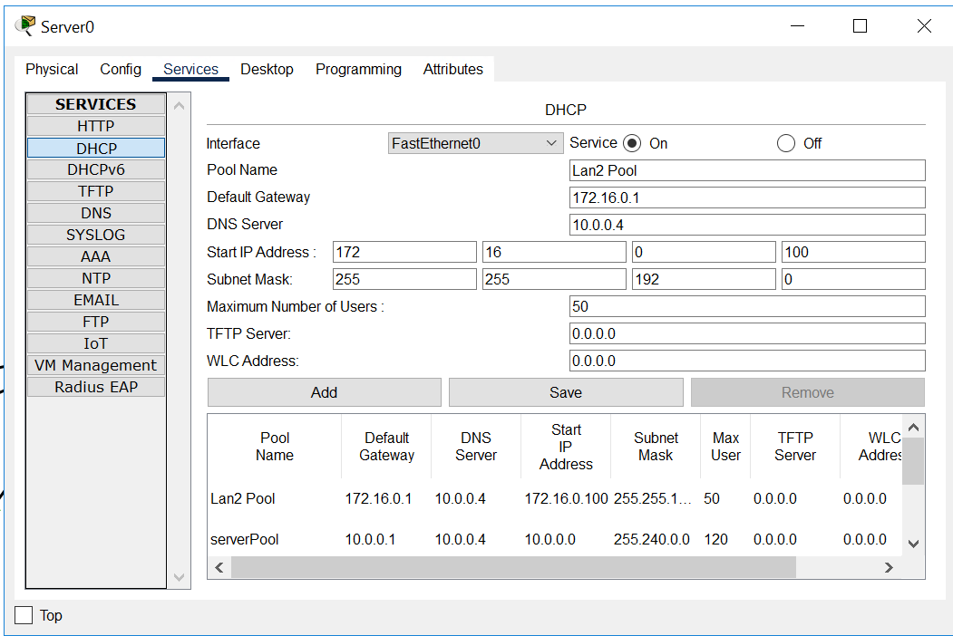
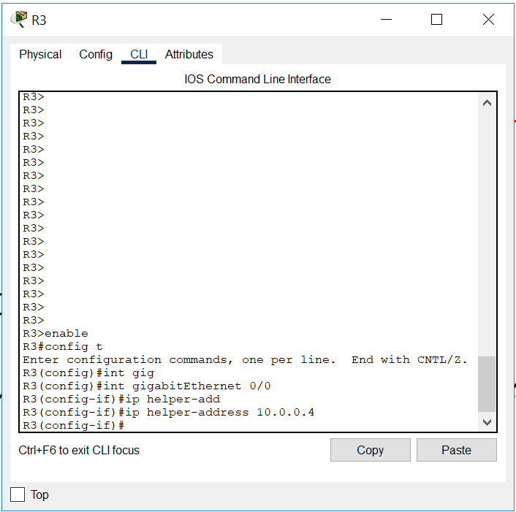
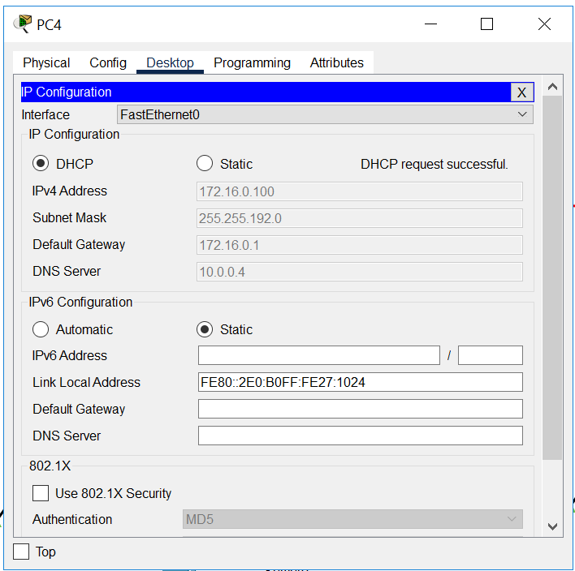
Ip should be assigned by dhcp

DNS server

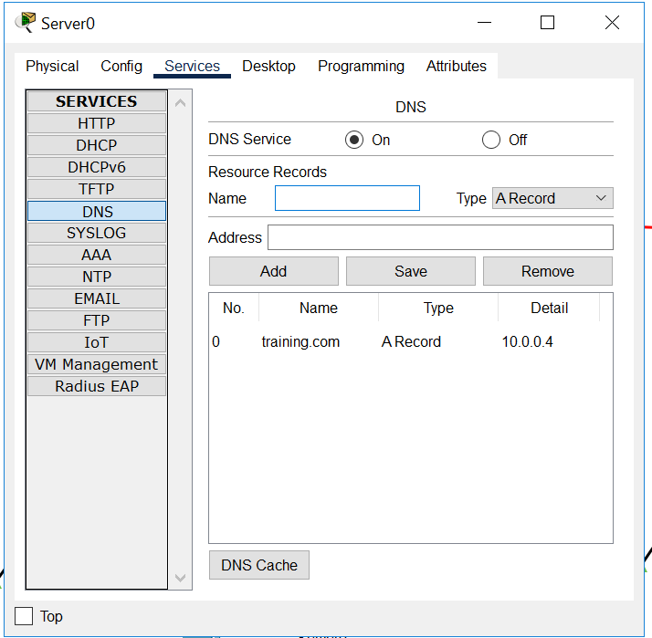

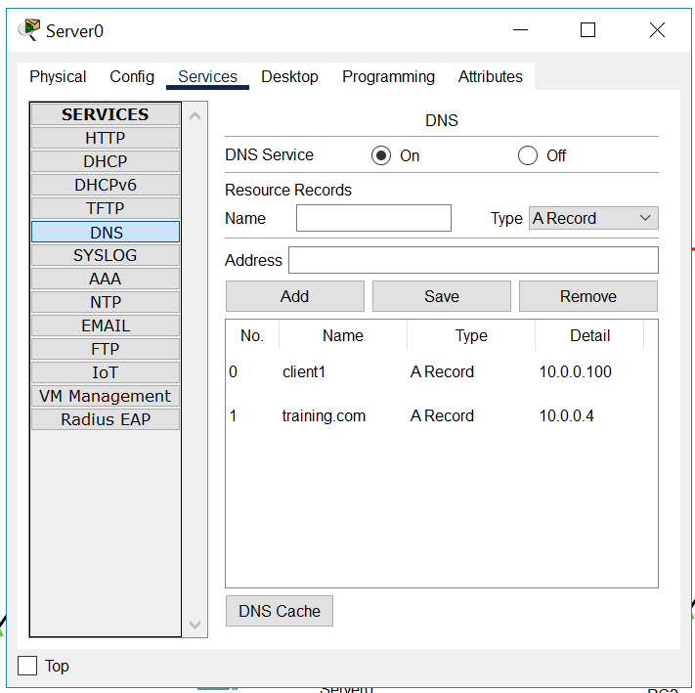
Take pc that has ip from dhcp
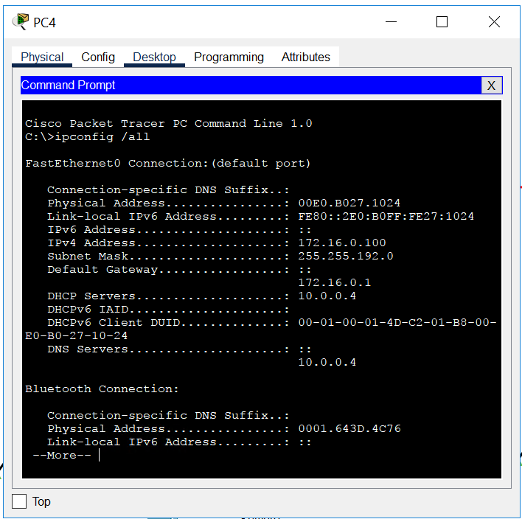
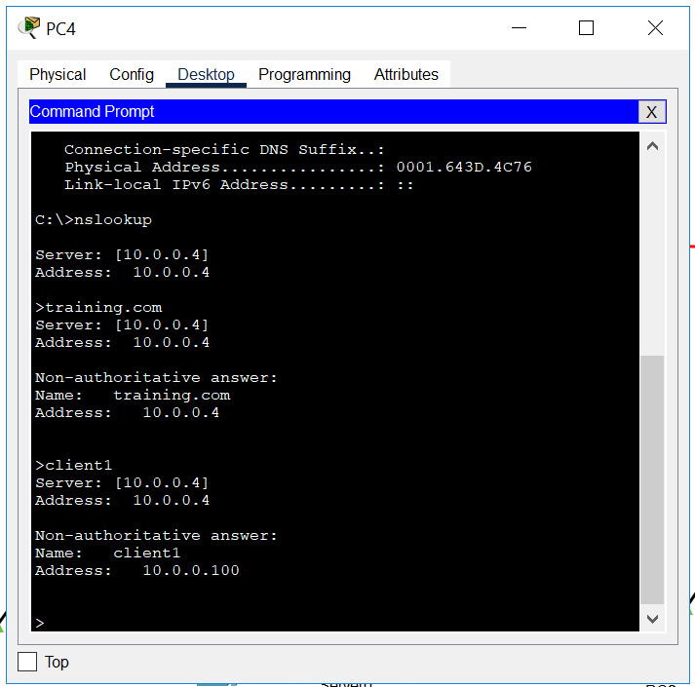
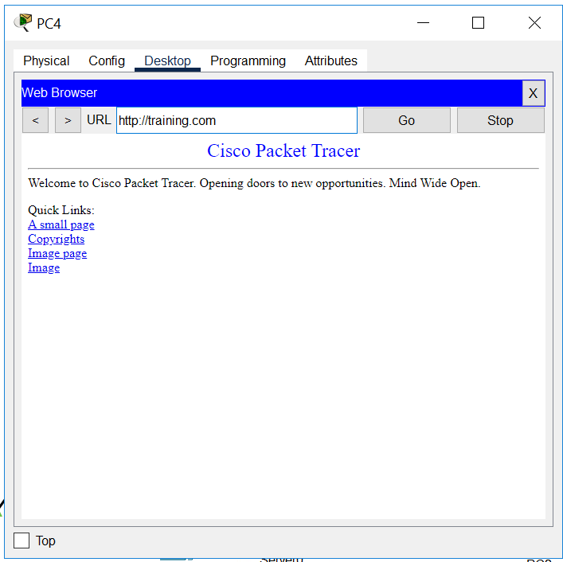
Now in pc with static ip config
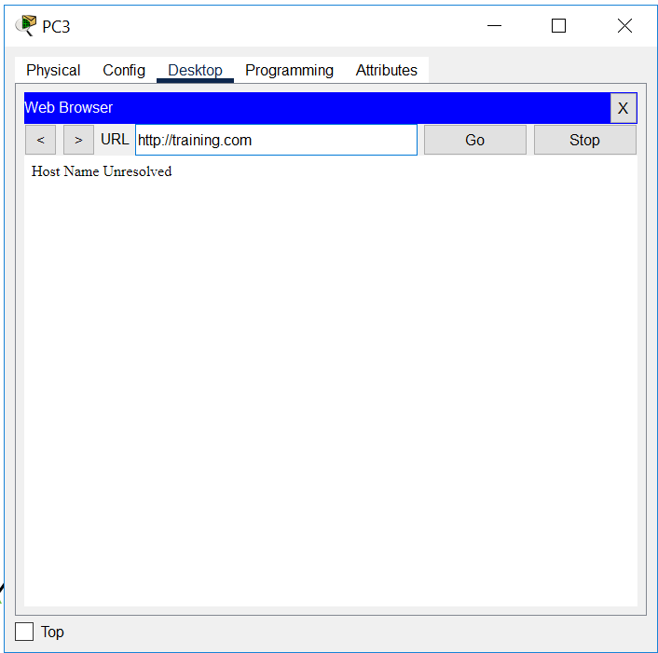

Route redistribution
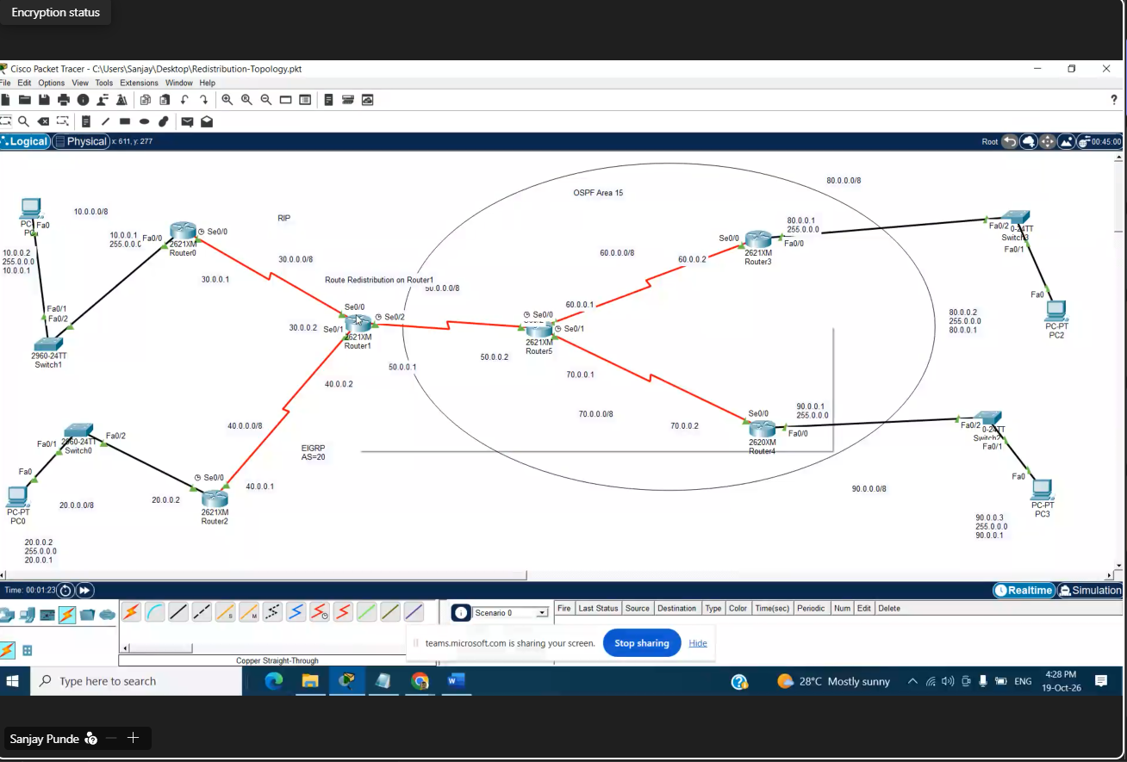

September 19

VLAN
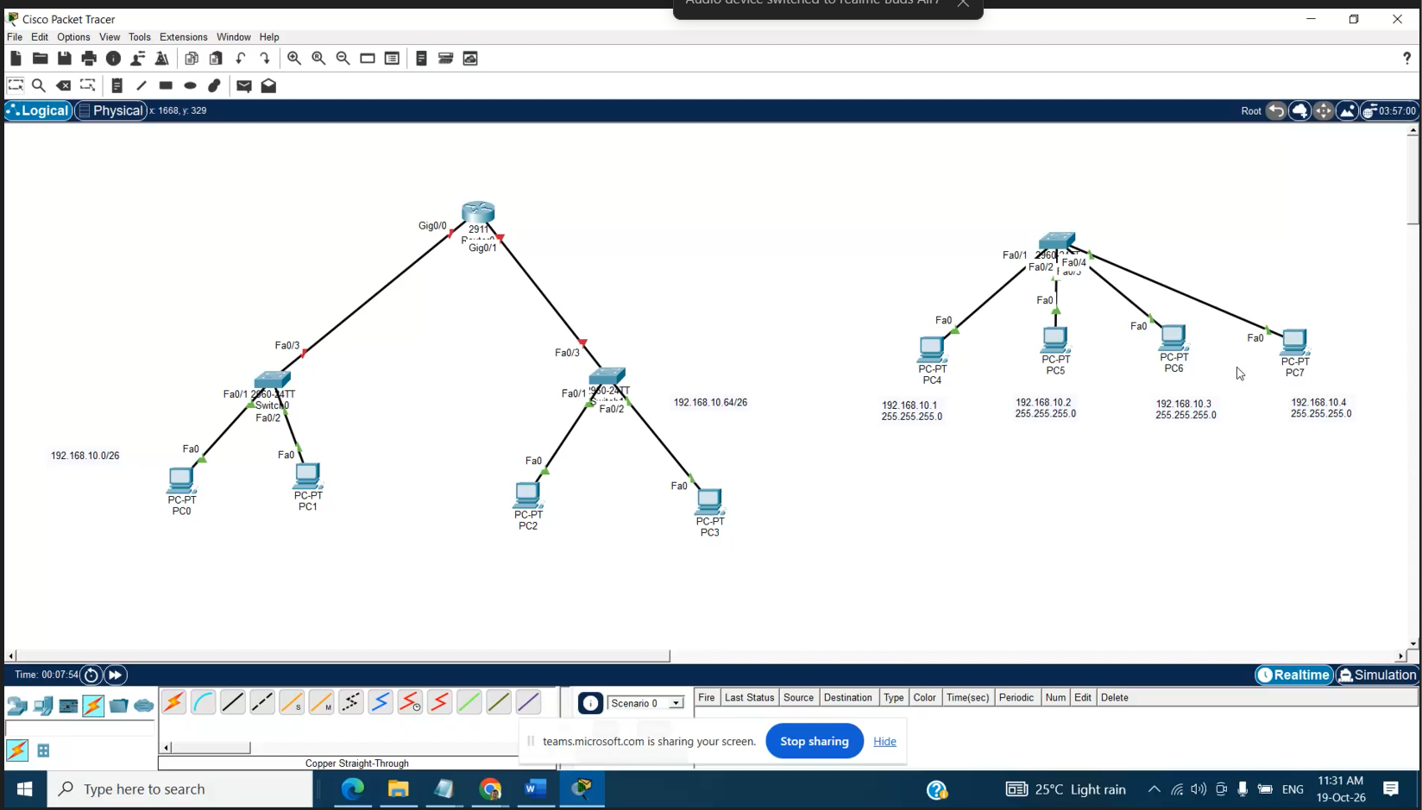
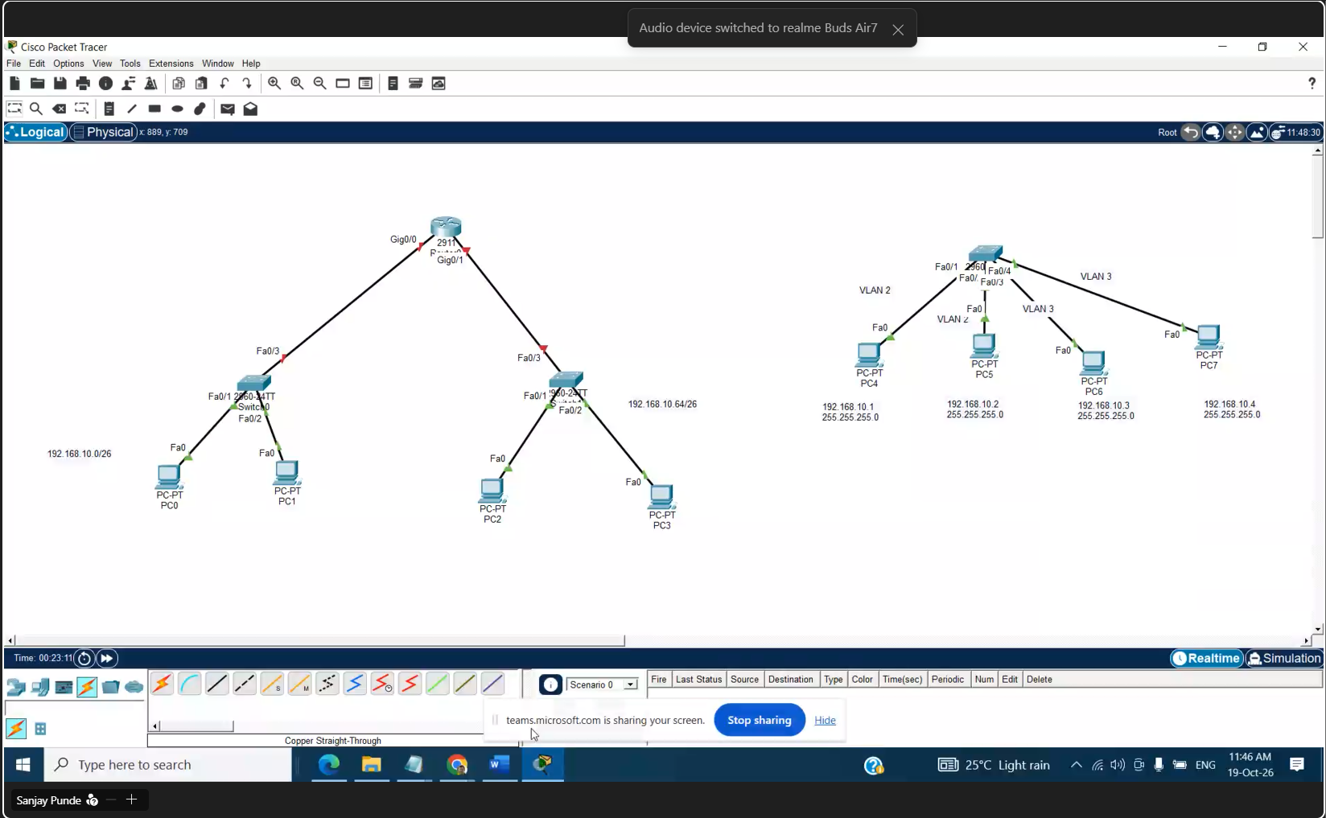
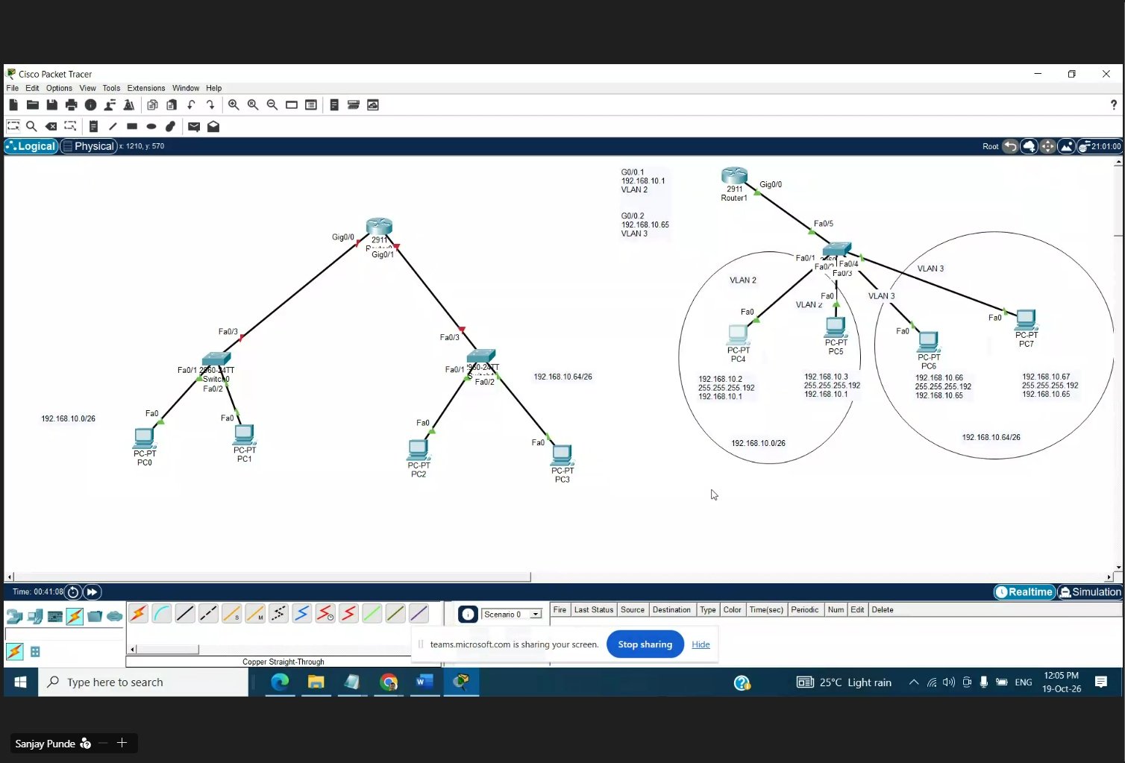
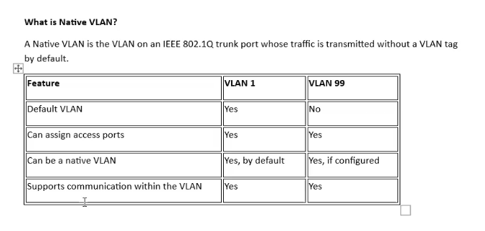
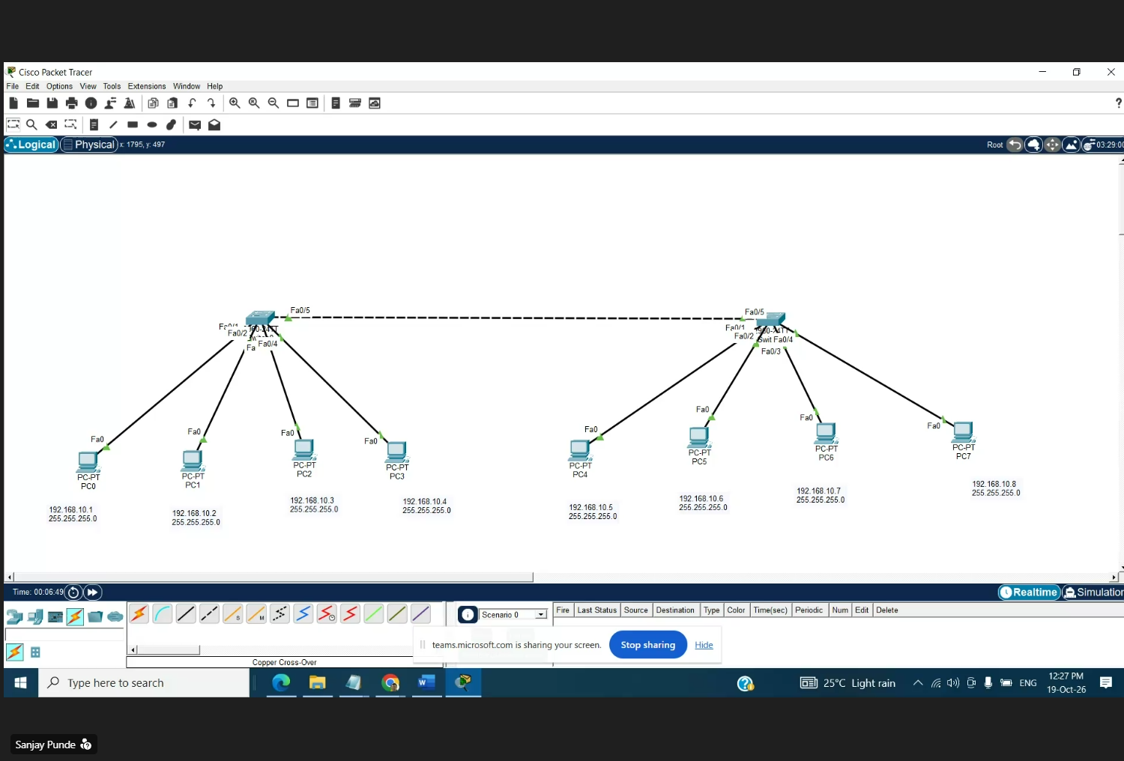
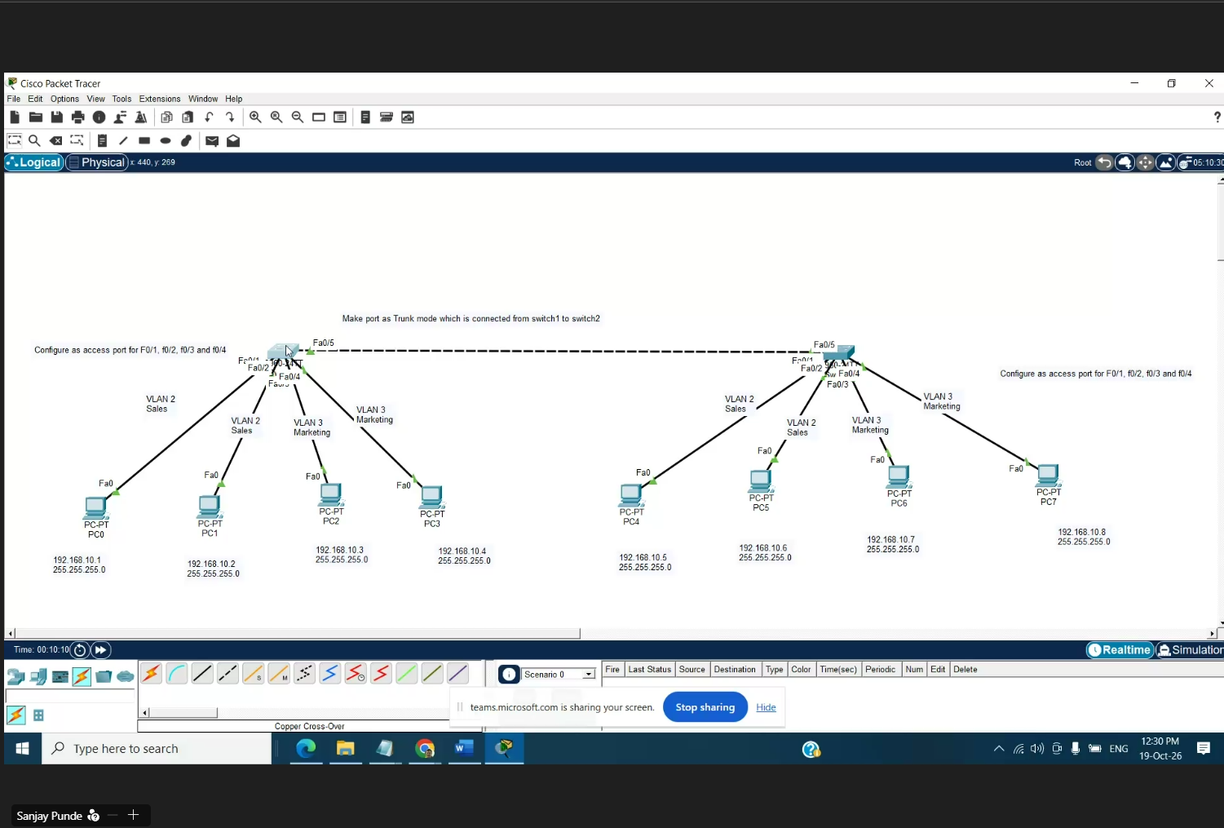
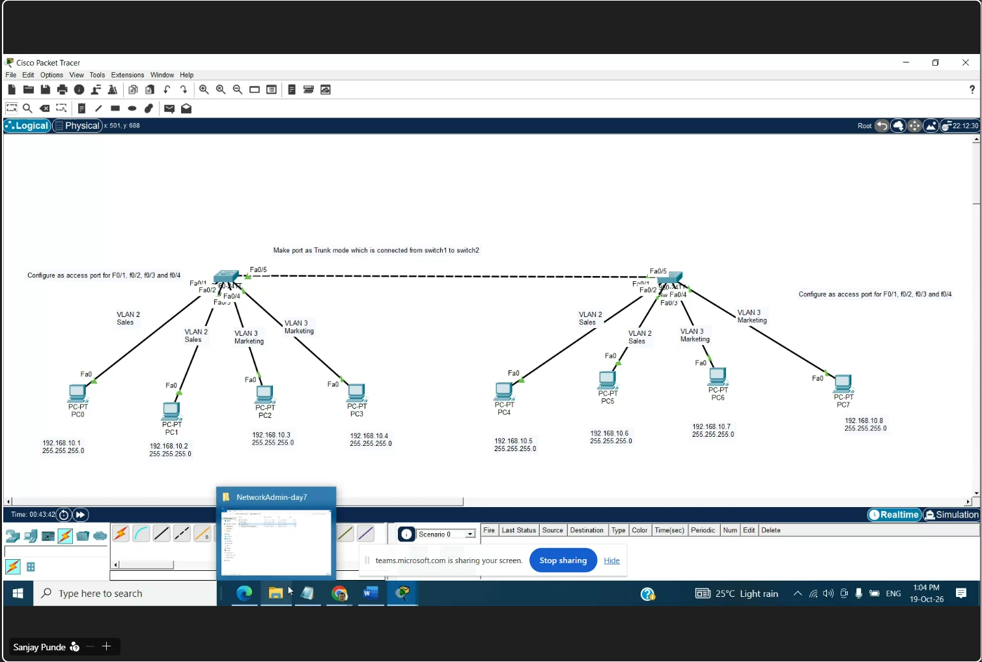
Save this file as vlan
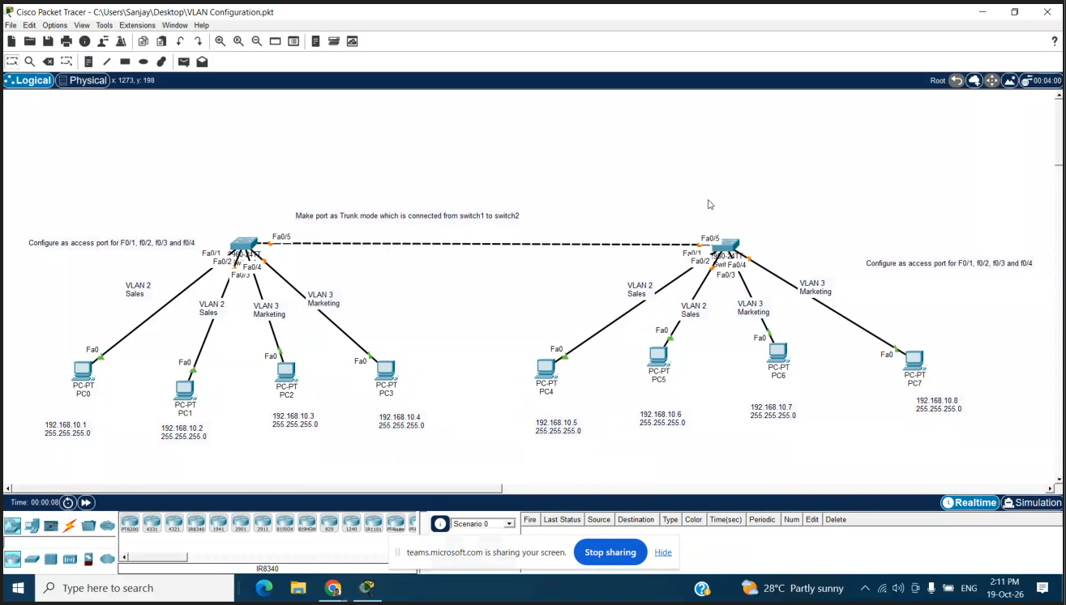

AFTER BREAK
SOMETHING ELSE
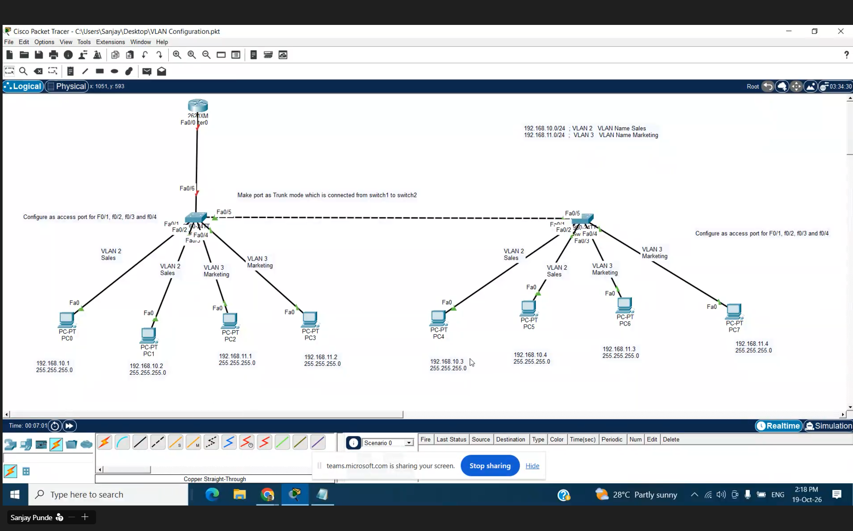
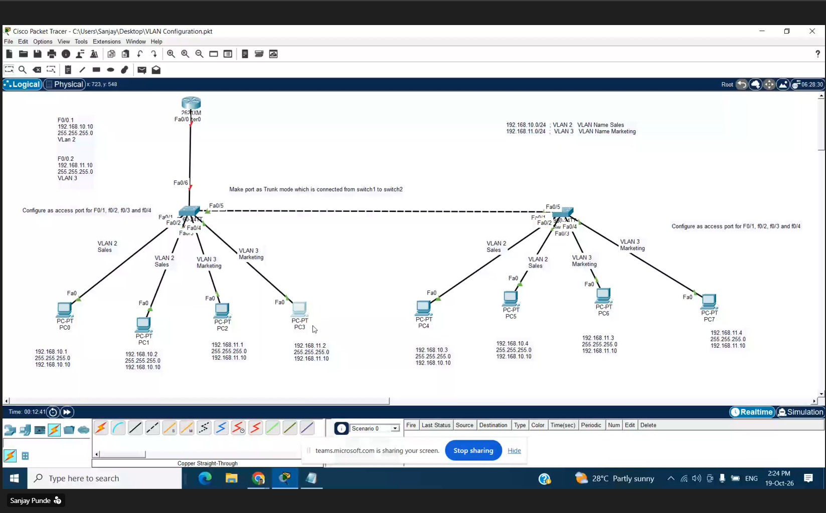

Layer 3 switch vlan
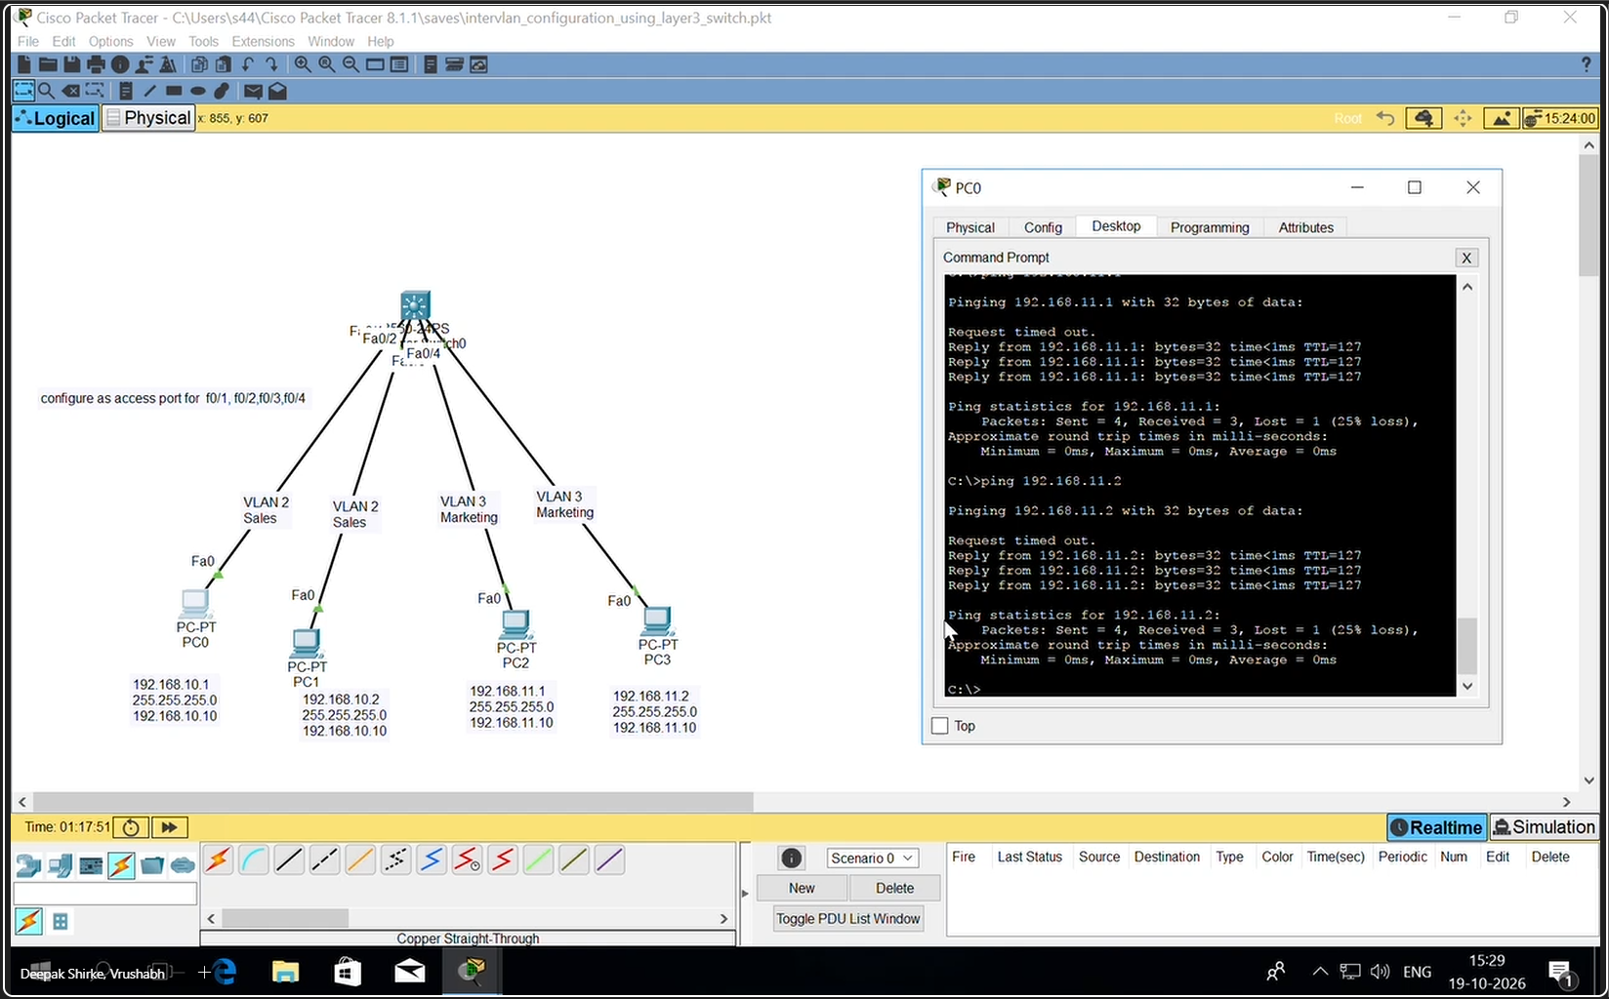

DAY 8 21 October

VTP

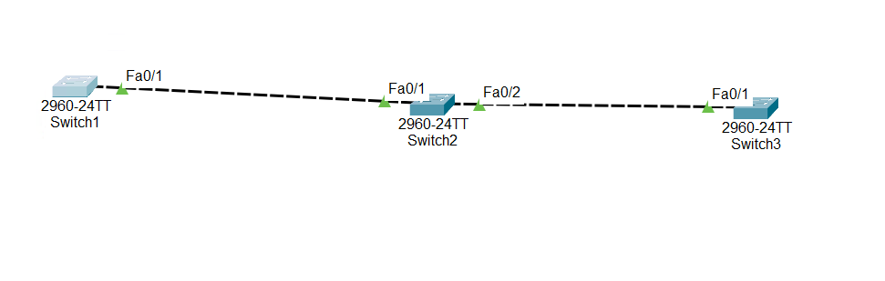
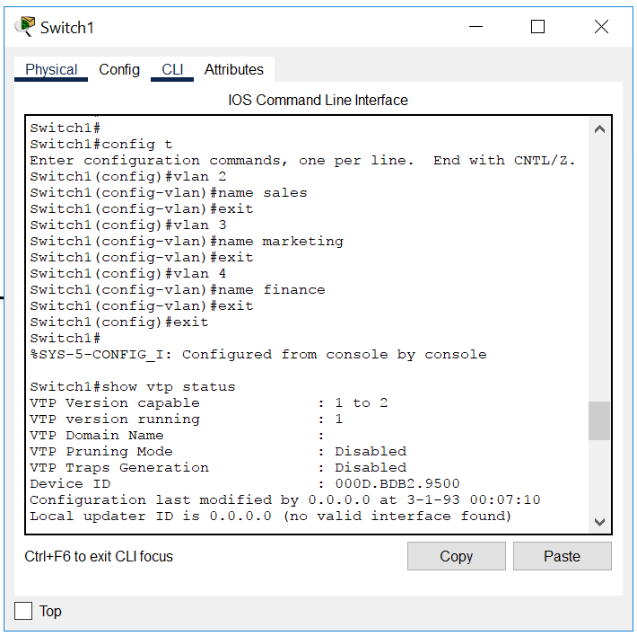

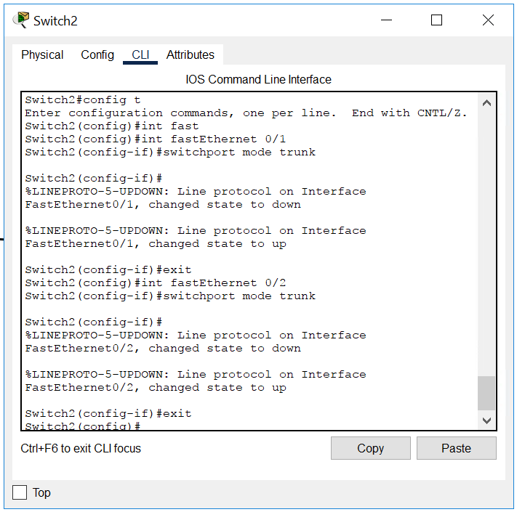
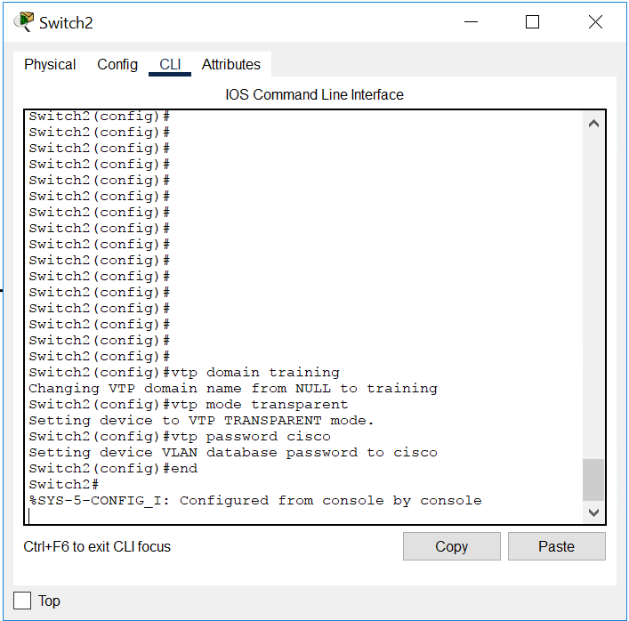
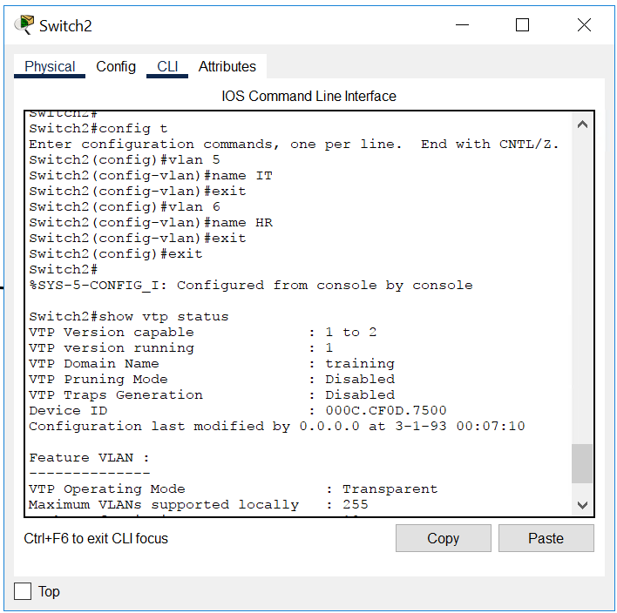
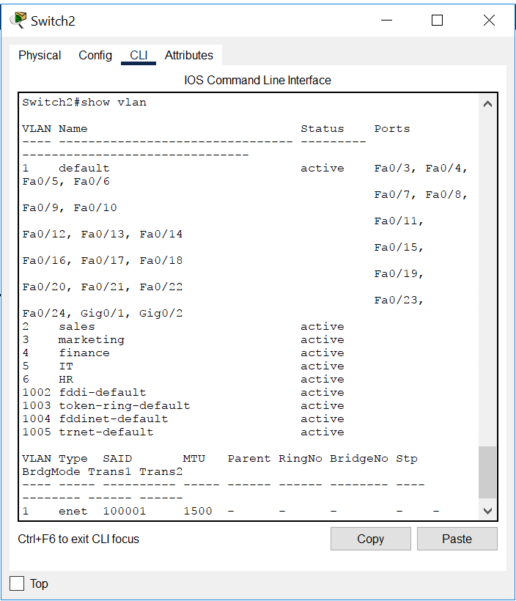
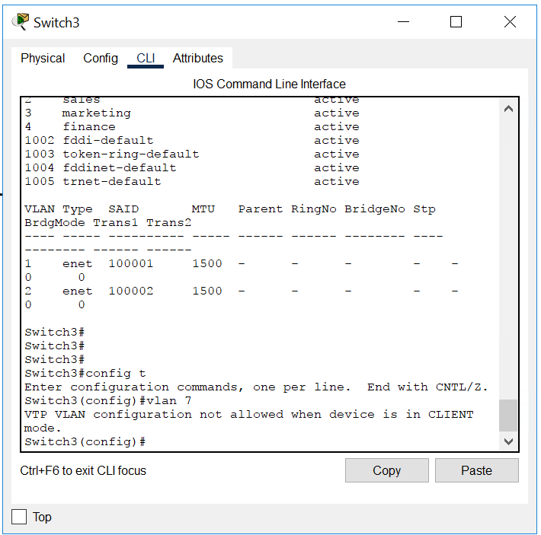

Refer to pics from mobile
Implementation not done properlu
3 vtp mode server transparent and client
Server 3 vlan
Transparant 2 vlans only 2 visible
Client only 3 from server visible

DTP

Refer mobile for all pics
Show interface trunk

PORT SECURITY
Refer mobile for all commands
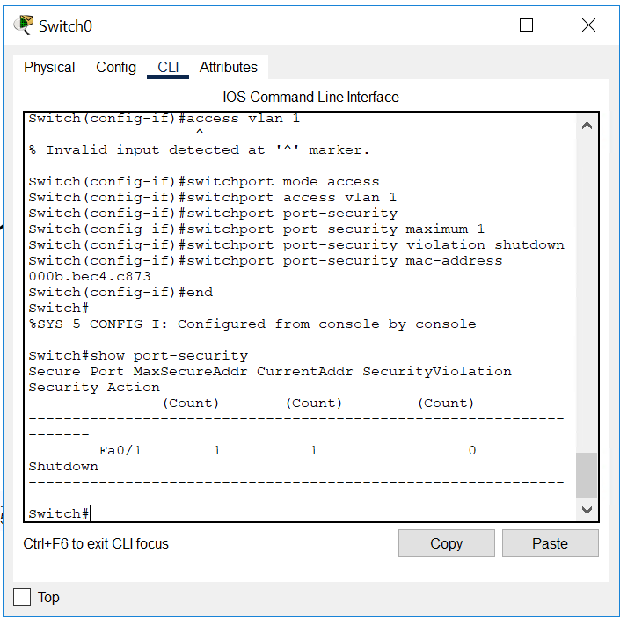
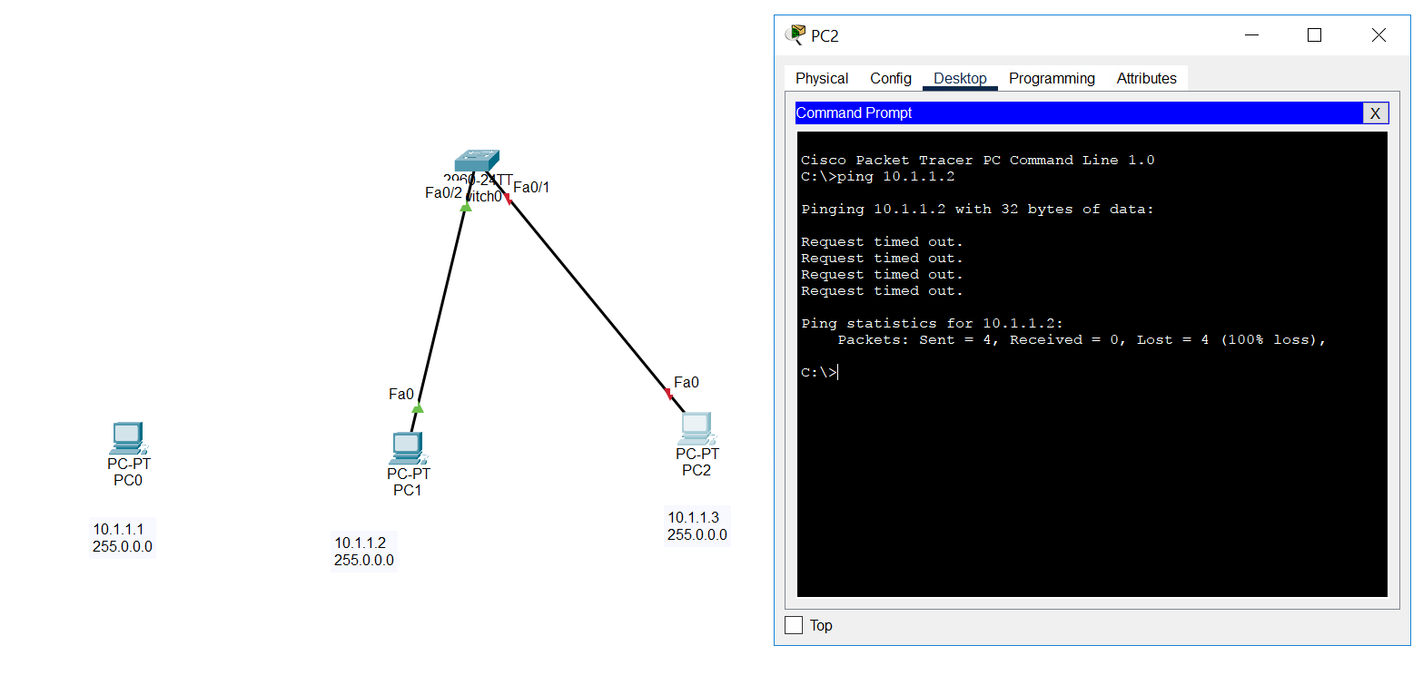

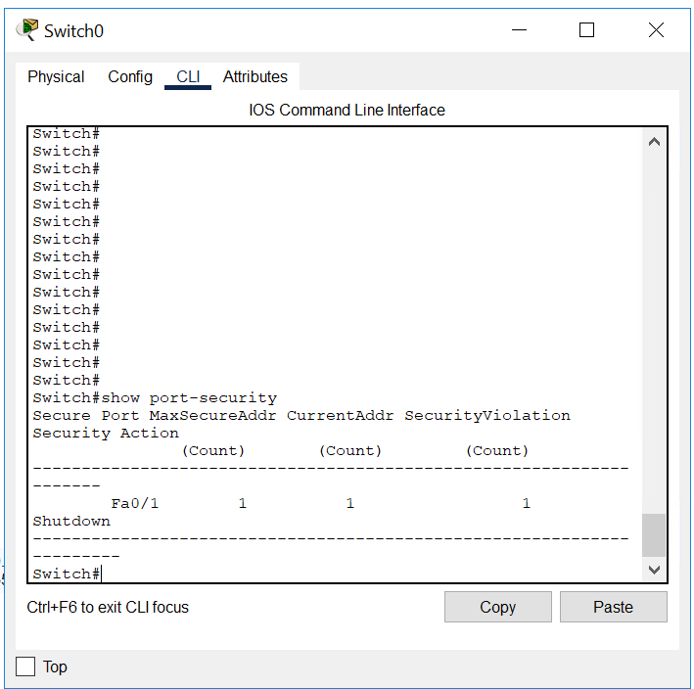

STP SPANNING TREE PROTOCOL

